Đay

MINISTRY OF EDUCATION AND TRAINING

FPT UNIVERSITY

FACTORS AFFECTING ACADEMIC PERFORMANCE OF STUDENTS AT FPT UNIVERSITY CAN THO

Advisor: Le Canh Bich Tho

Students: Nguyen Le Ngoc Han (CS150443) Tran Hai Lam (CS150436) Nguyen Nhu Quynh (CS150785)
Course: Graduation Thesis (GRI491)

A thesis submitted in partial fulfillment of the requirements for the degree of Bachelor of Business Administration Thesis at
FPT University in 2023

ABSTRACT
The Grade Point Average (GPA) holds immense importance within the education system in Vietnam. GPA plays a crucial role for students who aspire to pursue further studies after graduation or transfer to another institution. Many universities, professional training centers, and academic programs require a minimum GPA for accepting students into their programs. Moreover, GPA is also a significant factor in the job application process, as it demonstrates the candidate's diligence, knowledge, and learning abilities.
Additionally, a high GPA proves beneficial in securing scholarships and financial aid from organizations, schools, or the government. Such scholarships help alleviate the financial burden for students and support them in continuing their education. Furthermore, some companies may specify a minimum GPA requirement when hiring for specific positions, particularly those demanding specialized knowledge. GPA can influence one's access to future career opportunities.
The importance of GPA has piqued the interest of academic researchers. While there have been numerous studies discussing factors influencing students' GPA, few have delved into the specific context of GPA determinants in Vietnam, especially at FPT Can Tho University.
This research was conducted through an online survey using Google Forms, involving 422 students from FPT Can Tho University. The results revealed significant correlations between family, teacher competence, English level, social networks, part-time job, joining the club, learning in groups, peer pressure and infrastructure with the GPA of FPT Can Tho University students.
In addition to some limitations, these findings have contributed significantly to students, universities, and educational administrators in understanding the factors influencing academic performance and aiding the development of strategies and academic programs to enhance the quality of education. However, the study also emphasizes that GPA is just one aspect of academic achievement, and other factors such as personal progress and soft skills should be considered for a comprehensive understanding of students' academic success.

DECLARATION BY AUTHORS
This thesis consists of our original work and contains no material previously published or written by others unless appropriate references have been made in the text. The content of our thesis is the result of work we have done since the beginning of the GRI491 course and does not include work that has been submitted to qualify for any degree or diploma. in any other university or tertiary institution.
We acknowledge that electronic and printed copies of our thesis must be submitted to the University Library and that according to FPT University policies and procedures, these are made available for research and study, unless an embargo period has been approved. of the Dean of the Faculty of Economics.
We acknowledge that the copyright of all materials contained in our thesis belongs to the copyright holder(s) of that material. Where appropriate, we obtained copyright permission from the copyright holder to reproduce the material in this thesis.

ACKNOWLEDGEMENTS
It is imperative to acknowledge that the success of our research was not solely attributed to our individual efforts, but rather a collective endeavor with the invaluable contributions of numerous individuals.
First and foremost, we extend our profound gratitude to Ms. Le Canh Bich Tho for her exceptional guidance as our research supervisor and professional editor. Her unwavering support was pivotal in bringing this project to fruition.
Furthermore, we extend our sincere appreciation to each member of the research team for their unwavering commitment, skills, and dedication in completing this work. Their collaborative efforts and support in complementing each other's strengths were instrumental in achieving the project's goals.
Last but certainly not least, we express our heartfelt thanks to the participants who generously devoted their time to participate in data collection. Additionally, we are grateful to the lecturers at the study site for graciously allowing us to visit their classrooms for data collection purposes.
In conclusion, this research would not have been possible without the combined efforts and support of all the individuals involved. Their invaluable contributions have undoubtedly enriched the completion of this thesis.

GRI491_ THESIS GROUP WORK
Student’s code | Name | Action Taken | Proportion of  contribution (100%)
CS150443 | Nguyễn Lê Ngọc Hân | - Writing content  - Join survey students  - Manipulating and storing SPSS result  - Make report slides  - Buy gifts for students when interviewing + print papers  - Write email | 100%
CS150436 | Trần Hải Lâm | - Writing content  - Write interview questions  - Make report slides | 100%
CS150785 | Nguyễn Như  Quỳnh | - Writing content  - Join survey students  - Make report slides | 100%

Note: Our team ensures an equitable distribution of tasks among all members, and with the support of both the teacher and team members, the entire group successfully accomplishes 100% of the tasks required to execute this project.

TABLE OF CONTENTS
ABSTRACT 2
DECLARATION BY AUTHORS 3
ACKNOWLEDGEMENTS 4
LIST OF FIGURE 8
LIST OF TABLE 10
LIST OF ACRONYMS 11
Chapter 1 12
INTRODUCTION 12
1.1. Background 12
1.2. Research objectives 14
1.3. Significance of the study 14
1.4. Scope and limitations 15
1.5. Thesis structure 15
CHAPTER 2 16
LITERATURE REVIEW 16
2.1. Theories of Academic Performance 16
2.2. Factors affecting student Academic Performance 17
2.3. Previous studies on students’ academic performance 24
2.3.1. International studies 24
2.3.2. Vietnamese studies 25
2.4. Research model and hypotheses 26
2.5. Supplementary theory 27
2.6. Summary of the chapter 33
CHAPTER 3 34
RESEARCH METHODOLOGY 34
3.1 Research design 34
3.2. Research methodology 35
3.2.1. Sampling 35
3.2.2. Method of analysis 35
3.3. Measuring instrument 37
3.4. Summary of the chapter 42
CHAPTER 4 43
DATA ANALYSIS AND FACTOR AFFECT ACADEMIC PERFORMANCE OF STUDENT FPT UNIVERSITY CAN THO 43
4.1. Sample characteristics 43
4.2. Assessment of measurement scale 53
4.2.1. Testing reliability of scales 54
4.2.2. Exploratory Factor Analysis (EFA) 57
4.2.3. Revising the research model 61
4.3. Testing model and hypotheses 63
4.3.1. Testing model 63
4.3.2. Testing hypotheses 66
4.4. Summary of the chapter 70
CHAPTER 5 71
CONCLUSION, LIMITATIONS, IMPLICATIONS AND RECOMMENDATIONS 71
5.1. Conclusion 71
5.2. Recommendations 72
5.3. Limitations 73
5.4. Recommendations for further research 73
REFERENCES 74
APPENDIX 83

LIST OF FIGURE

Figure 1 | The research model proposed by Thao, N.T.P. (2014)
Figure 2 | The model and research hypotheses proposed
Figure 3 | The model Theory of Reasoned Action (Ajzen & Fishbein, 1975)
Figuge 4 | The model Theory of Planned Behavior
Figure 4.1.1 | Descriptive statistics of gender
Figure 4.1.2 | Descriptive statistics of major and courses
Figure 4.1.3 | Descriptive statistics of education of father and mother
Figure 4.1.4 | Descriptive statistics of hometown
Figure 4.1.5 | Descriptive statistics of occupation of father and mother
Figure 4.1.6 | Descriptive statistics of average family income
Figure 4.1.7 | Descriptive statistics of GPA in high school
Figure 4.1.8 | Descriptive statistics of jobs orientation or university enrollment  counseling
Figure 4.1.9 | Descriptive statistics of GPA of the most recent semester at FPT  University Can Tho
Figure 4.1.10 | Descriptive statistic of the family’s encouragement and teachers’  interaction
Figure 4.1.11 | Descriptive statistics of Lecturers are willing to provide course  materials for students and are available to answer questions and support students during the learning process
Figure 4.1.12 | Descriptive statistics of the type of English certificate that the student took the exam and the student's level of English is sufficient to gain access and understanding of the study materials  and exams
Figure 4.1.13 | Descriptive statistics of how effective it is in applying existing  English skills to the learning process and exams
Figure 4.1.14 | Descriptive statistics of time students spend on social networks in  a day
Figure 4.1.15 | Descriptive statistics of “What do you usually use social networks  for? And what are the social media channels you often use?”

Figure 4.1.16 | Descriptive statistics of time for students to organize group study in a week, organize group study to help students easily system knowledge and the organization of group study will help achieve  better learning results than self-study
Figure 4.1.17 | Descriptive statistics of students peer pressure
Figure 5 | The model of Schema
Figuge 6 | The model of Assimilation and Accommodation
Figuge 7 | The model of connectivism
Figuge 8 | The model of Sociocultural theory
Figuge 9 | The model of More Knowledgeable Other
Figuge 10 | The model of Zone of Proximal Development and Scaffolding
Figuge 11 | Research procedure
Figuge 12 | The research model is revised

LIST OF TABLE

Table 4.1 | Cronbach’s Alpha test results
Table 4.2 | KMO and Bartlett's Test
Table 4.3 | Total Variance Explained
Table 4.4 | Rotated Component Matrix(a)
Table 4.5 | Result of EFA with academic performance (AP)
Table 4.6 | Summary results of testing scales
Table 4.7 | Correlations (a)
Table 4.8 | Model Summary (b)
Table 4.9 | ANOVA (b)
Table 4.10 | Coefficients(a)
Table 4.11 | Regression coefficients

LIST OF ACRONYMS

GPA | Grade Point Average
EFA | Exploratory factor analysis
KMO | Kaiser-Meyer-Olkin
AP | Academic performance
FA | Family
TC | Teacher competence
EL | English level
SN | Use social networks
PJ | Part-time job
CLUB | Joining the club
LG | Learning in groups
PP | Peer Pressure
INFRA | Infrastructure
SPSS | Statistical Package for the Social Sciences
H | Hypothesis

Chapter 1

INTRODUCTION
This chapter will commence by presenting the background research, elucidating the research objective, and highlighting the study's significance. Subsequently, the chapter will delve into the research's scope and limitations. Finally, an overview of the thesis structure will be provided.

Background

Currently, Vietnam is a developing country with many outstanding achievements in all fields from life, economy-society to education. Vietnam is constantly innovating to match the trend of world integration (Hieu, 2021). With the attention of the Party and State, Vietnam's education has made positive changes, achieving many outstanding achievements, making a significant contribution to the development of the country. Some important milestones marking Vietnam's educational achievements are the completion of primary education universalization in 2000; in 2010 complete education universalization junior high school; in 2014 complete primary education universalization at the right age level I; in 2017 has completed education universalization preschool for children 5 years old and from 2018 5-year-old kindergarten children in areas with difficult socio-economic conditions will be free of tuition fees. The above milestones have shown that the scale and education network in Vietnam is growing. Besides, the quality of education and training has been raised and has a new development which is evidenced through world intellectual playground competitions. Vietnam first participated in the PISA competition in 2012 and ranked 7th in Mathematics and 8th in Science. Meanwhile, the US is only 36th in Mathematics and 28th in Science. In 2015, in the rankings published by the OECD based on Mathematics and Science, Vietnam ranked 12th and was much higher than the 28th position of the US (Anh & Thuong, 2018).

In Vietnam, Academic performance are often assessed through the grade point average (GPA) of the subjects. GPA is very important and is also used in most universities. GPA has also become a tool for businesses to evaluate a recent graduate and consider hiring employees (Rumberger et al., 1993). GPA becomes a criterion for colleges and universities to apply for admission and scholarships as well. In addition, many student organizations,

financial aid programs or places where students want to do an internship also have GPA requirements. Moreover, when you have just graduated from school and have no work experience, your GPA will be an advantage to help you be more appreciated by businesses when applying for a job (Wise, 1975). Actually GPA is important but not everything. Enterprises also evaluate candidates through many other aspects such as experience, soft skills and working attitude of each person (Viet & Thao, 2012). A high GPA will show that you are a person with the ability to think, work hard to explore and learn, but soft skills and attitudes will help you easily adapt to the new working environment. Therefore, in parallel with achieving a high GPA, other aspects must be developed to increase employment opportunities.

In the world, there have been a number of studies on the factors affecting Academic performance of students. Stephen, Welman and Jordaan (2004) concluded that English ability has a direct impact on Academic Performance. Tariq et al., (2012) said that students using social networks often appear distracted to other topics without focusing on the educational topic, wasting time. Stroebele et al. (2013) suggested that getting enough sleep and proper physical activity will increase the cumulative score. In another study, Sothan, S. (2019) presented research results with a number of factors such as English ability, students themselves and family economic status has a strong impact on academic performance. The most recent study, Tadese, M., et al (2022) concluded that teachers have a relatively important role in student academic performance.

In Vietnam, according to a research paper by An, et al. (2016) concluded the research results that the capacity of lecturers and students themselves are the two main factors that directly affect academic performance. Another study, Thao, et al (2020) also gave similar results as the faculty factor, and in the study also found that the infrastructure factor plays an important role in with academic performance. In addition, the research of Viet & Phuong (2017) concluded that factors such as learning preferences (belonging to the student's own factors), parental motivation (belonging to family factors), facilities, pressure from friends are factors that have an impact on learning results.

In the Mekong Delta, research on the average score of students is still limited. Especially, the lack of information about factors affecting students' Academic performance makes students sometimes confused in the study process as well as the job application process after graduation. In addition, the lack of information on the factors affecting the GPA

of the subject also affects the teaching, enrollment as well as the reputation of the school. The study was carried out with the desire to find out the causes that can affect the academic performance of students, thereby making some suggestions for the following purposes:

- For the school, we hope that our research can help the school to recognize the causes that affect academic performance that students may be suffering from, so that the school can easily supporting students in the learning process and improving student learning result.
- For students, we hope that our research paper can provide students with a more general view of the importance of Academic performance. Help students recognize the causes of poor academic performance so that they can be overcome, and at the same time promote the factors that are having a positive impact on their learning results. Thereby improving the learning result of students themselves better.

Research objectives

This study aims to analyze the factors affecting the academic performance through the GPA of students at FPT Can Tho University and assist university stakeholders in developing effective strategies and to enhance academic achievement and educational experience students in overall.

The specific objectives of the study include:

- Present the learning situation of FPT students through GPA.

- Identify factors affecting academic performance.

- Propose solutions based on the results obtained after the analysis.

Significance of the study

The main target of this research was to assess the current situation of students' learning quality, offer several recommendations to enhance academic performance, and elevate the overall educational standards of the institution. Additionally, it furnishes valuable insights and practical references for administrators, researchers, high school students, and incoming university freshmen.

Scope and limitations

The research topic is "Factors affecting academic performance of students at FPT Can Tho University", so the scope of the research only focuses on students at FPT Can Tho University. The limitation of this study is that it is not possible to collect data according to the Ratio scale because the survey respondents refused to provide the answers directly. Therefore, the authors analyze the data of the observed variables by nominal and interval scale.

Thesis structure

This thesis report is presented with the following structure:

Chapter 1. Introduction: Give an overview of the current state of the education industry, research problems, research objectives, research scope and limitations of the research topic.

Chapter 2. Literature review: Provide some definitions of Academic performance, conclusions of previous studies on factors affecting student academic performance.

Chapter 3: Research methodology: Introduce the research model and put forward the research hypothesis, use appropriate research methods to evaluate the scale of testing the research model and research hypothesis. Research methods will include sampling method, survey data collection process and analytical method.

Chapter 4: Data analysis and findings: Present sample descriptive statistics, survey response rate, evaluate the scales and give the results of model and hypothesis testing.

Chapter 5: Discussion, conclusion and recommendations: Summarize and discuss the results of the research topic, thereby proposing solutions to improve and enhance the academic performance for students.

CHAPTER 2

LITERATURE REVIEW
The focus of this chapter is to present the theories that have shaped the concept and some statements about the results of previous studies on factors affecting academic performance. Over the years, a lot of research has been conducted on this topic. Factors that are believed to have an impact on academic performance will be represented. Based on this document, research hypotheses and research models are proposed.

Theories of Academic Performance

Academic performance is considered as what learners want to know, understand and be demonstrated at the end of a learning phase (Adam, S. 2006). According to Talib, Sansgiry (2012), academic performance are the measure of an individual student, a teacher or an institution that has accomplished a short-term or long-term educational goal as measured through a cumulative grade point average. Similarly, students' academic performance is assessed through the GPA (An, et al., 2016; Dung, et al., 2017). GPA has also become a tool for businesses to evaluate a recent graduate and consider hiring employees (Rumberger et al., 1993). According to the Cambridge University Reporter (2003), academic performance is often characterized by students' examination results. GPA is used as a measure to evaluate academic performance. In some countries, GPA is assessed on a scale of 4.0. GPA scores range from a minimum of 0 (Grade F) to a maximum of 4.0 (Grade A). The GPA system signifies that a higher score corresponds to a stronger academic performance by the student. Hence, GPA serves as an effective metric for assessing student learning achievements. (Jayanthi, S. V., 2014). Meanwhile in Vietnam, the Vietnamese education system evaluates GPA using a 10-point scale that includes both undergraduate and graduate programs.

Furthermore, various other studies propose that academic performance serves as an evaluation of students' knowledge and skills gained during the learning process, particularly in school subjects (Tam, 2010; Hoa, et al., 2018). Research by Kumar & Lal (2014) stated that knowledge is not only related to the content that students absorb but also affects other aspects such as cognitive, emotional, social, and physical development. Similarly, academic

achievement can include a wide variety of educational outcomes, from earning a diploma to a student's moral development (York et al., 2015).

Factors affecting student Academic Performance

    - Family

The academic performance of university students is frequently influenced and significantly impacted by their family, as evidenced by several studies by Román, Cuestas and Fenollar (2008); Matsuoka (2015); Prodan et al. (2015); Atolagbe et al. (2019). Román, Cuestas and Fenollar (2008) found a positive relationship between family support and academic achievement. They argue that economic resources in the home contribute positively to access to additional educational opportunities, which in turn can improve student academic performance. Matsuoka (2015) supports this view by asserting that household economic capital is associated with the availability of educational resources and opportunities. Students from families with higher economic resources are more likely to have access to better learning conditions such as hiring tutors, providing adequate learning facilities, which can have an impact positively affect student academic performance. On the other hand, Prodan et al. (2015) emphasize that low family income can be a barrier to access to higher education. Financial constraints can limit a student's ability to pay for tuition, study materials, and other essential resources, resulting in lower academic performance.

In addition, Atolagbe et al. (2019) found a significant correlation between parental occupation and student academic achievement. Specifically, students whose parents work in government agencies tend to achieve better academic results. Research shows that stable employment and socioeconomic status associated with government jobs can provide an environment conducive to student academic success. Besides, parental involvement and involvement also contribute to student academic performance. Research by Spera (2005) indicates that parental care, expressed through concern, support and encouragement have a significant impact on helping students achieve higher grades and maintain academic achievement.

    - Teacher competence

Teaching and communication competence is not only a fundamental task of a university lecturer, but it is also an important criterion to evaluate an individual, a teaching group, and even more so, the quality and reputation of a university. There is a perception

that good teachers can make a difference in student progress (Rivkin, Hanushek, & Kain, 2005). This shows that when teachers have good teaching capacity, they will make a difference to students' learning results, students easily absorb lessons, remember deeper knowledge and expand their thinking, thereby helping students achieve better academic results. Several studies have concluded that teaching quality is one of the main factors affecting students' optimal achievement (Marzano, 2003; Walberg, 2006; Stanca, 2006; Hattie, 2009).

According to the research by Trang, et al. (2014) and An, et al. (2016) suggested that the teacher's ability to communicate influences the acquisition of knowledge in the learning process. In addition, Akiri and Ugborugbo (2009) perceive the proficiency of lecturers as a multi-faceted instructional framework comprising interconnected elements intended to impart knowledge to learners. Along with that, the organization method of the subject and interaction with students also affect student academic performance. Moreover, the active teaching method of faculty will also bring about positive academic performance for students (Thao, et al., 2020; Hoa, et al., 2018). According to Muzenda (2013), lecturers hold a pivotal role within a school, influencing students' academic success as they can shape students' attitudes and facilitate improved outcomes. Nonetheless, to accomplish this, lecturers must possess suitable competence. Ganyanpfu (2013) supports this notion by emphasizing that a lecturer's teaching abilities can be gauged by their aptitude to comprehend and convey their knowledge concepts effectively to the students.

    - English level

In our increasingly globalized world, English proficiency has gained immense significance, given that it has become the most widely spoken language worldwide, encompassing approximately 1 billion people when considering both native and non-native speakers (Ilyosovna, N. A., 2020). In higher education settings, English has also evolved as a predominant medium of instruction. Numerous studies have explored the correlation between English proficiency and the academic performance of university students.

Research conducted by Stephen, Welman, and Jordaan (2004) as well as Ghenghesh (2015) revealed a positive association between English proficiency and academic achievement. Students with higher English language skills consistently outperform their peers with lower language proficiency. This evidence highlights the advantages of

possessing strong English language proficiency, as it enhances the learning experience and academic outcomes compared to students with lower language proficiency levels. Since students' English proficiency will include both reading and understanding lectures from teachers, their acquisition of knowledge will depend heavily on understanding English. Similarly, research by Dafouz and Camacho-Miñano (2016) has shown that students taught in English score higher and perform better in exams than students taught in their mother tongue. They suggest that EMI enhances students' academic achievement by providing them with the opportunity to develop both their English proficiency and specialized knowledge. This implies that exposure to English as a medium of instruction positively affects academic performance. For overseas student, if students' English is poor, it will become a reason for being isolated by local students and lecturers (Trice, 2007). This proves that English proficiency has an indirect impact on students' academic achievement.

With the training program of FPT University, the documents as well as the exercises and exams are used 100% in English. This is the reason that English proficiency has become one of the factors that have an impact on academic performance included in our research.

    - Use of social networks

Social networking sites are online platforms that enable users to connect with one another, allowing them to share personal information, pictures, and interests on their profile pages. These sites facilitate interaction by allowing users to post statuses and images, fostering communication and the formation of friendships (Junco & Cole-Avent, 2008). Notably, students exhibit the ability to multitask, employing social media to send and receive text messages, make plans with friends, and engage in online activities while socializing in person (Jacobsen and Forste, 2011).

Various studies have highlighted the prevalence of social networking site usage among students. Junco (2011a) reported that as of 2012, over 90% of students were using Facebook. Additionally, Smith & Caruso (2010) found that 90% of students were active on social networking sites, with 97% using Facebook daily. Furthermore, Junco & Cotten (2012) and Junco (2011a) demonstrated that students spent approximately 1 hour and 40 minutes per day on Facebook and checked the platform around 5.75 times daily.

In the contemporary world, social networks have become an integral and frequently used tool for individuals, given the advancements in science and technology. In the realm of

education, Kabilan, Ahmad, & Abidin (2010) assert that social media can play a constructive role in promoting student engagement and facilitating better learning experiences. Social networks serve as spaces for students to share ideas, interact, and exchange knowledge effortlessly, offering teachers easier access to students (Al-Khalifa and Garcia, 2013). Students' use of social media can ruin their lives as well as have a negative impact on academic achievement. When using social networks, students are often distracted to other topics without focusing on the educational topic, wasting time (Tariq et al., 2012). According to research by Alberto Posso (2016), frequent use of online social networks, such as Facebook or texting significantly affects scores in math, reading and science. Furthermore, the results show that the more often you use the internet for these activities, the worse your score will be. Another study found that most of the people surveyed used social networks for chatting purposes, not learning purposes (M. Owusu-Acheaw & Agatha Gifty Larson, 2015).

    - Part-time job

Currently, many students not only focus on studying but also do part-time jobs to earn extra income. Most Western countries, especially the United States and Australia, have an increasing number of students working part-time (Maarja Beerkens, 2011). Part-time jobs can help students earn a small amount of income that can be used for expenses and reduce the burden on the family, part-time jobs also help students get exposed to work early and easier to apply for jobs after graduation (Wang et al., 2010). For students with financial difficulties. They work part-time jobs to be able to get some money to spend on accommodation and living expenses in a month, reducing the burden on the family. Therefore, studying while working becomes a path that poor students choose.

Research by Hovdhaugen (2015) shows that students who work full-time are less likely to complete their studies than students who work part-time or those who do not work at all. This shows that when students spend too much time on part-time jobs, their academic performance will be dragged down, because the time that students spend studying is reduced. The fact that students work part-time while studying at university can cause students to be distracted in their studies and have a number of other negative effects such as missing class sessions, being late for school, not getting enough sleep leading to difficulty concentrating and little use of school facilities resulting in very little access to learning resources (Moreau & Leathwood, 2006; Curtis, 2007).

Part-time jobs can help students access the working environment sooner and acquire some knowledge and skills during the part-time job. However, it will bring negative consequences to students' academic results if students do not know how to manage their time and balance part-time work and study. In fact, there have been many students who prioritized part-time work over study, unable to balance between school and work, leading to reduced academic results, unstable health due to overwork and overwork. Therefore, it is necessary to clearly determine the extent of the influence of part-time work on students' academic results, thereby building advanced solutions so that students can balance between study and part-time work.

    - Joining the club

The university environment is not simply an environment for students to learn specialized knowledge, the learning environment is also a place for students to accumulate basic skills before going to work because soft skills are highly valued by employers. If you become the head of the club, you can improve your leadership skills. According to the research results of Darling et al. (2005), adolescents who participate in extracurricular activities have a more positive attitude in learning and have higher academic aspirations leading to better academic performance.

However, research by Eccles and Barber (1999) has shown that a group of clubs are in bad shape, club members are in discord, or students only participate in free time without any reasonable placement will have negative consequences on their academic performance. This implies that if students are too focused on joining the club, not being able to balance between participating in the club and their own studies will lead to a decrease in academic performance. Besides, participation in sports clubs can reduce students' motivation to study (Van Etten, et al., 2008).

Therefore, it is necessary to clearly determine the influence of participation in extracurricular activities, especially on campus clubs, on students' academic results, thereby proposing plans to ensure both Joining the club and having good academic results is extremely important. FPT University has many clubs established, and also has a large number of students participating, some students join more than 2 clubs. Therefore, the Join the club factor included in our research is essential.

    - Learning in groups

In the current educational context, group learning is gradually becoming an extremely effective teaching strategy and is applied in most universities. Group study can help a group of students work together to realize and achieve a common academic goal (Johnson & Johnson, 1999). Studies have shown that group study can enhance student performance. Research by Kraus et al. (2009) demonstrated that when students learn in a collaborative environment, this is group learning where group members encourage each other, thereby increasing learning motivation. Through the above evidence, it has been proven that group study has a great impact on student academic performance. In addition, another study by Peterson and Miller (2004) found that students reported more positive learning experiences in a collaborative environment than in traditional lectures.

Group learning not only affects academic performance, but also has a significant impact on student attitudes and persistence, which has been studied by Springer et al. (1999). Furthermore, various group learning methodologies advocate for heterogeneous group composition, which includes students of different abilities and backgrounds, rather than homogeneous groups. This approach aims to reflect the diverse skill sets and experiences present in the class. Research indicates that heterogeneous groups tend to exhibit more elaborative thinking, engage in providing and receiving explanations, and demonstrate perspective-taking during discussions. Consequently, these factors contribute to deeper comprehension, improved reasoning abilities, and enhanced long-term retention (Johnson & Johnson, 1999).

Moreover, studies conducted by Wang, S. L., & Lin, S. S. (2007) also affirm the positive impact of collective efficacy on group performance and discussion behaviors. Students with higher collective efficacy not only demonstrate the use of more advanced cognitive skills during group discussions but also achieve better academic performance.

    - Peer Pressure

According to the definition of peer pressure, Kirk (2000) argues that peer pressure is that within a group of people of the same age, there is one person who does not initially fit the norms of this group. Over time, this person's values and attitudes gradually change to conform to the group's standards. Another name for peer pressure is peer influence, which refers to a person's behavior change in order to meet the needs or standards of a group of people (Burns & Darling, 2002).

In a learning environment, friends play an important role in exchanging knowledge and experiences. In the study of Sacerdote (2001) found that grades will be higher when students have unusually good classmates. A number of other studies have also stated that the competition in learning among students in the university environment is often developmentally competitive (Thao, 2014). The influence of friends on a student's academic performance is also demonstrated in a number of studies by Dancer, et al., (2015) and Hill (2017).

Through international and Vietnamese studies on the topic of GPA and Academic performance, peer pressure has been mentioned. However, studies in Vietnam do not have a certain emphasis on this factor. Our research has included this factor for research. Based on the results, it is possible to propose the best recommendations and solutions to solve this problem. Especially in the education system of FPT University, there is still no research on this issue. We consider this peer pressure factor to be the novelty of the study.

    - Infrastructure

The facilities of a classroom play an important role in facilitating an effective learning experience for students. Facilities include furniture, classroom design, classroom lighting, information technology-related teaching systems and equipment. (Earthman, 2002; Tanner & Lackney, 2006). By providing facilities and other information technology related teaching materials, students enjoy the classroom which helps them to score well in exams (Kausar, Kiyani & Suleman, 2017). Kilel (2012) has noted that the availability of comprehensive facilities and instructional resources in the classroom is considered a key factor in improving student academic performance. Class size and the quality of the physical environment have been shown to affect student achievement. Olufemii and Olayinka (2017) suggest that students in smaller, well-equipped classrooms tend to do better than their peers in larger classes. According to Lyons (2001), the quality and arrangement of a school's physical facilities have a significant impact on the effectiveness and performance of teachers, as well as the academic achievement of students.

Additionally, Suleman, Aslam, and Hussain (2014) have identified five factors that contribute to the classroom environment: visual factor, acoustic factor, thermal factor, spatial factor, and time factor. The visual factor pertains to the lighting quality in different parts of the classroom, encompassing the construction and layout that ensures adequate access to

natural and artificial light while minimizing unwanted disruptions. The acoustic factor is crucial, considering the noise level in the environment. Poor classroom acoustics can have adverse effects on the learning environment, as constant exposure to noise can impede students' cognitive performance (Higgins et al., 2005). The thermal factor refers to the climatic conditions within the classroom, including heating and ventilation, which play an important role in creating a favorable and comfortable atmosphere that can positively influence students' behavior and performance. The spatial factor relates to the efficient utilization of space, while the time factor involves the duration of a student's participation in class activities and tutorials.

There have been many studies on the impact of infrastructure factors on student academic performance and academic achievement. The infrastructure factor is an indispensable factor and appears throughout the research works on this topic. The continued inclusion of this factor in the theme emphasizes the importance of this factor for the school to improve and provide the best facilities for students.

Previous studies on students’ academic performance

International studies
Research by Urien (2003) has shown the research results that factors such as personal characteristics, family circumstances and study discipline have an impact on students' academic performance. In the study by Betts and Morell (1998), it was reported that factors such as gender, ethnic origin, family income and economic environment were the source of differences in GPA. In the SAT-M exam, Young and Fisler (2000) found that male students had higher test scores, which was caused by socioeconomic differences such as male students having from high-income families.
Several studies have confirmed that family has an important role and has a strong impact on student academic performance (Román, Cuestas and Fenollar, 2008; Matsuoka, 2015; Prodan et al., 2015; Atolagbe et al., 2019). Several studies conclude that the quality of instruction is one of the main factors affecting student achievement (Marzano, 2003; Walberg, 2006; Stanca, 2006; Hattie, 2009). English proficiency has a positive relationship with student academic performance as demonstrated by a number of studies such as Stephen, Welman and Jordaan (2004); Trice, (2007); and Ghenghesh (2015); Dafouz and Camacho- Miñano (2016). Research Al-Khalifa and Garcia, (2013) argue that the social network will

provide students with a means of easier communication in learning and have a positive impact on academic performance. However, some other studies have suggested that excessive or inappropriate use of social networks for learning purposes will have a negative impact on academic performance (Tariq et al., 2012; Lin, et al., 2013; M. Owusu-Acheaw and Agatha Gifty Larson, 2015; Alberto Posso, 2016). Research by Moreau & Leathwood (2006), Curtis (2007) and Hov Haugen (2015) have found that part-time work has a significant negative impact on the academic performance of students who are working part- time. Some argue that joining the club has a positive impact on academic performance Darling et al. (2005). In addition, it has been suggested that if students do not balance club participation and study, there will be a significant negative impact on academic achievement (Eccles and Barber, 1999; Van Etten, et al., 2008). The studies of Kraus et al. (2009), Peterson and Miller (2004), Wang, S. L., & Lin, S. S. (2007) demonstrated the positive impact of group learning on academic performance. There are also some studies that prove that when playing with people with good academic ability, your grades and academic performance will also improve, this is a peer pressure factor (Sacerdote, 2001; Dancer, et al., 2015; Hill, 2017). And finally, the Infrastructure factor, which has also been shown to have a strong impact and appears throughout the research project on factors affecting student academic performance.

Vietnamese studies
In Vietnam, there are also some research studies on this topic. According to research by Viet, V. V. and Phuong D. T. T. (2017), 7 factors have been identified that have an impact on student academic performance, including: intellectual capacity, learning preferences (students themselves), parents' motivations (family), facilities, scholarships (schools), peer pressure, social pressure (society). Research by Thao, P. T. H., et al. (2020) concludes that there are 3 factors affecting student academic performance: students themselves, teachers' teaching methods and facilities. An, N.T.T. et al. (2016) proved that lecturers play an important role and have an impact on student academic performance.
The following research model is proposed by Thao, et al. (2020):

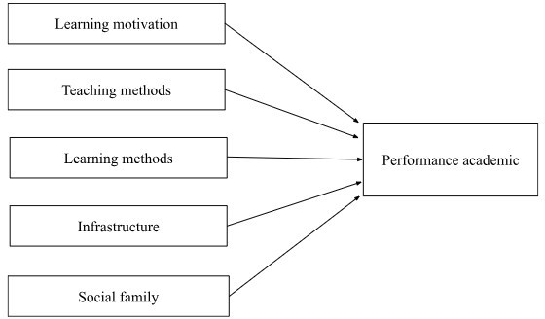

Figure 1. The research model proposed by Thao, et al. (2020)

Research model and hypotheses

Factors that are thought to have an impact on Academic performance have been demonstrated in previous studies. The authors propose a research model and are described as follows:

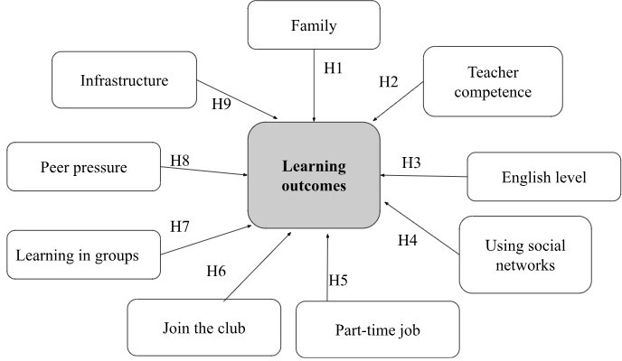

Figure 2. The model and research hypotheses proposed

The research model includes 9 independent variables: (1) Family, (2) Teacher competence, (3) English level, (4) Using social networks, (5) Part-time job, (6) Join the club,
(7) Learning in groups, (8) Peer pressure, (9) Infrastructure; and a dependent variable is
Academic performance.

The research hypotheses proposed by the research team are as follows:

Hypothesis 1: Family has a positive impact on Academic performance.

Hypothesis 2: Teacher competence has a positive impact on Academic performance.

Hypothesis 3: English level has a positive impact on Academic performance. Hypothesis 4: Using social networks has a negative impact on Academic performance. Hypothesis 5: Part-time job has a negative impact on Academic performance.
Hypothesis 6: Join the club has a negative impact on Academic performance. Hypothesis 7: Peer pressure has a positive impact on Academic performance. Hypothesis 8: Learning in groups has a positive impact on Academic performance. Hypothesis 9: Infrastructure has a positive impact on Academic performance.

2.5. Supplementary theory
2.5.1. Behaviorism Theory
According to behavioral theory, learning is a conditioned reflex process, a person's behavior change is the result of his or her response to events in the environment. Behavior theory mainly emphasizes memorization, the learning process is based on reward and punishment regulations, the teacher is the subject of knowledge, providing stimuli to create conditioned reflexes in learners.
Currently, there are two classical models used to measure behavioral intention. According to Theory of Reasoned Action, the foundation of the rational behavior theory was initially formulated in 1967 by Fishbein, and later refined and expanded upon by Ajzen and Fishbein (1975). According to this framework, individuals selecting the most suitable methods for a given behavior. With the Theory of Planned Behaviour, developed from the theory of Reasoned Action (Ajzen and Fishbein, 1975), which was created due to the limitation of presumption of the previous theory that human behavior is entirely controlled by reason. Similar Like the TRA theory, the central factor in the theory of planned behavior is the individual's intention to perform a certain behavior.
Belief in action results
Attitude
Evaluate action results
Behavior
Intention the behavior
Subjective standards

Belief in the standards of the people around

Motivation to comply with those around you

Figuge 3. The model Theory of Reasoned Action (Ajzen & Fishbein, 1975)
With a new theoretical model developed in 1991, the author believes that the intention to perform the behavior will be influenced by three factors such as attitude towards the behavior, subjective standards and perceived behavioral control.
Attitude towards the behavior

Behavior
Intention the behavior
Subjective standards
Perceived behavioral control

Figuge 4. The model Theory of Planned Behavior
2.5.2. Cognitivism Theory
The three basic elements of Piaget's cognitive development theory:
- Schema
- Piaget (1952, p.7) defined a schema as: “a cohesive, repeatable action sequence possessing component actions that are tightly interconnected and governed by a core meaning”.
- Wadsworth (2004) suggests that schemata (the plural of schema) be thought of as “index cards” filed in the brain, each one telling an individual how to react to incoming stimuli or information.
- Operations are more sophisticated mental structures which allow us to combine schemas in a logical (reasonable) way.
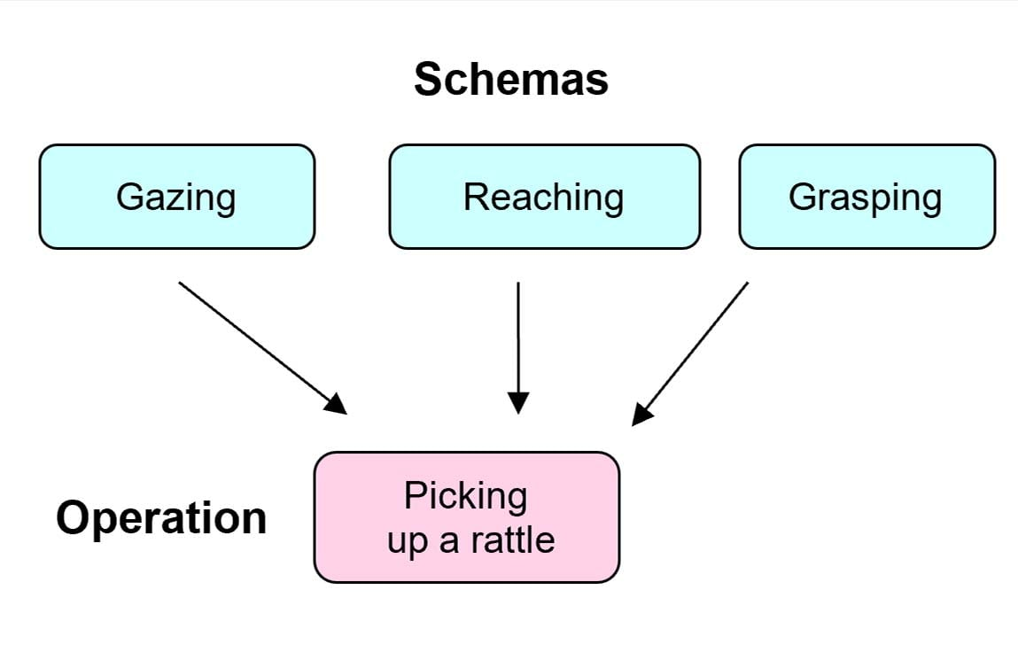
Figuge 5. The model of Schema
- Assimilation & Accommodation
- Assimilation: using an existing schema to deal with a new object or situation.
- Moderation: occurs when existing schema (knowledge) doesn't work, and needs to be changed to deal with a new object or situation.
- Equilibrium: is the force pushing development forward. Piaget believed that cognitive development does not proceed in a steady rhythm, but with leaps. Equilibrium occurs when the child's cognitive skills are able to process most of the new information through assimilation. However, an uncomfortable state of disequilibrium occurs when the new information does not match the existing ones (assimilation). Equilibrium is the driving force behind the learning process, when we don't want to be disappointed and seek to restore balance by mastering a new challenge (modulation). Once the new information is captured, the assimilation of the new schema continues until we need to correct it the next time.
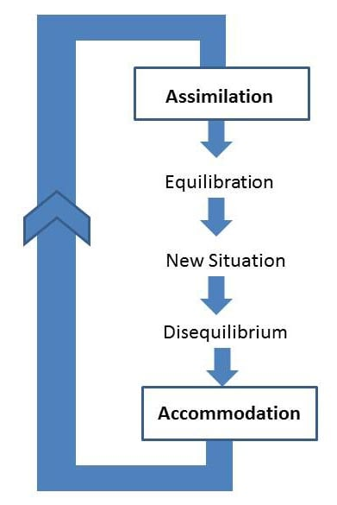
Figuge 6. The model of Assimilation and Accommodation
- The 4 stages of Piaget’s theory
Piaget divided children’s cognitive development into four stages; each of the stages represents a new way of thinking and understanding the world. He called them (1) sensorimotor intelligence, (2) preoperational thinking, (3) concrete operational thinking, and (4) formal operational thinking. Each stage is correlated with an age period of childhood, but only approximately. According to Piaget, intellectual development takes place through stages that occur in a fixed order and which are universal (all children pass through these stages regardless of social or cultural background). Development can only occur when the brain has matured to a point of “readiness”.
2.5.3. Connectivism Theory
Connectivism is a relatively new learning theory that suggests students should gather ideas, theories, and general knowledge from various sources but integrate them accurately. It was created in 2005 by theorists George Siemens and Stephen Downes. It's based on the idea that internet technology has created new opportunities for people to learn and share information online. It acknowledges that technology is integral to the learning process, and our continuous connectivity offers choices in how we learn. Both Siemens and Downes developed connectivism based on the limitations of behaviorism, cognitivism, and constructivism to explain the effects of technology on how we live, interact, communicate, and learn.
In the connectivist theory, learning starts when knowledge is activated by learners connecting and engaging within a learning community. Engagement leads to conversations between learners and other community members, including those who possess more expertise. In the context of the web 2.0 era, these conversations involve not only words but also images, such as videos, multimedia, etc. With web 2.0's emergence, learners can create Personal Learning Environments (PLEs), enabling both production and consumption of learning resources (Goldie, J.G.S. (2016)).
Goldie (2016) also asserts that connectivism affirms that knowledge and learning are distributed, meaning they're not located in any specific place but encompass networks formed from the interaction of individuals, society, organizations, and linking technologies.

Networks on social media platforms like Facebook also provide an effective foundation to enhance learner engagement with online learning, transforming students into active, enthusiastic learners who nurture the exchange of high-quality knowledge or ideas among all participants (Alalwan et al., 2019).
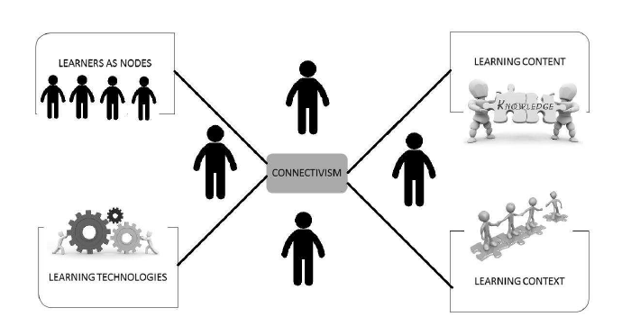
Figuge 7. The model of connectivism
2.5.4. Social Development Theory
In the theory of social development, it explains that socialization directly influences an individual's learning process. By engaging in communication with individuals who possess greater knowledge on a subject, such as peers or adults, we transmit knowledge and initiate the learning process. The central focus in Vygotsky's work is the social nature of learning and development. He believed that the ability to teach others and learn from others is a distinctive human trait (Moll, 1990).
Vygotsky's theory (1978) includes the following key concepts:
a/ Social Interaction and Collaborative Learning:
According to Vygotsky (1978), a child's significant learning takes place through social interaction with a knowledgeable tutor. This theory posits that students learn a lot through interactions with others, including peers and teachers. An environment that fosters such interactions can create a positive learning environment.
Research by An et al. (2016) suggests that a teacher's communication skills impact the acquisition of knowledge in the learning process.
Group learning can help students work together to achieve shared learning goals (Johnson & Johnson, 1999).
Studies have shown that group learning can enhance student performance. Kraus et al.'s research (2009) demonstrated that when students engage in cooperative learning, where group members encourage each other, it increases their motivation to learn.

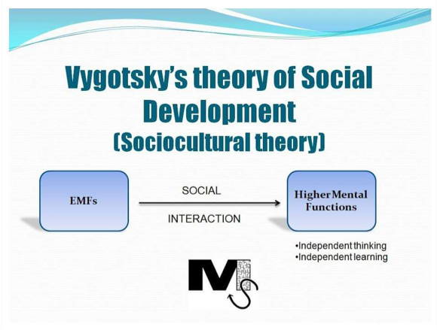
Figuge 8. The model of Sociocultural theory
b/ More Knowledgeable Other:
The More Knowledgeable Other is someone who has a better understanding and can explain things; it refers to individuals who possess a higher level of knowledge or expertise about a task, process, or specific concept. While the more knowledgeable other is often implied to be a teacher or an adult, it doesn't necessarily have to be. Sometimes, peers or individuals of similar age who have more knowledge or experience can also serve as the more knowledgeable other.
The More Knowledgeable Other can provide guidance and encouragement to students. Most of the time, the role of the more knowledgeable other is fulfilled by teachers, but peer collaboration can also be effective. In a student group, the more knowledgeable other often emerges among classmates as an influential leader (Sweet & Michaelsen, 2007).
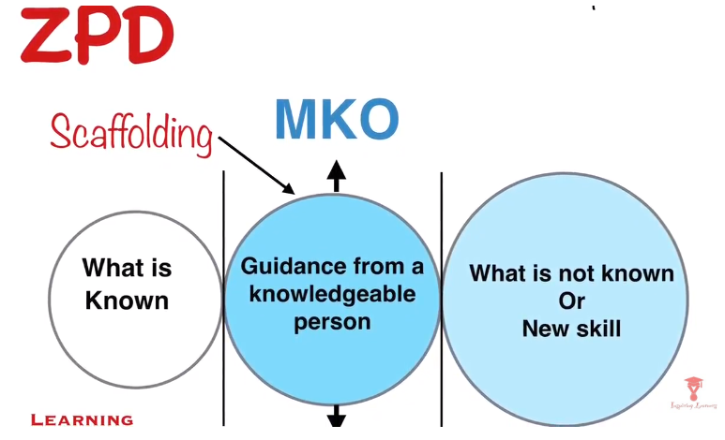

Figuge 9. The model of More Knowledgeable Other
c/ Zone of Proximal Development:
The Zone of Proximal Development is the gap between a student's actual developmental level determined by independent problem-solving and the potential developmental level determined through problem-solving under the guidance of an adult or in collaboration with more capable peers (Vygotsky, 1978, p. 86).
This theory emphasizes that students often have the potential to develop further than they can demonstrate independently. Teachers and peers can support them in tasks within this "zone of proximal development," playing a crucial role in enhancing learning performance.
(Rivkin, Hanushek, & Kain, 2005) suggest that effective teachers can make a difference in student progress.
Muzenda (2013) views lecturers as the most important factor in institutions, influencing students' achievement levels by changing their attitudes and helping them achieve better results. However, to do this, lecturers need appropriate skills.

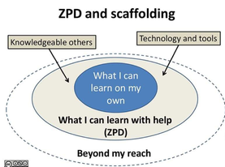
Figuge 10. The model of Zone of Proximal Development and Scaffolding

2.6. Summary of the chapter

This chapter introduces the definition of Academic performance and cites a number of studies that have found an impact on Academic performance. Provides an overview of references related to the research topic. From the review of documents, propose research hypotheses from there as a basis for proposing research models. Most of the factors in the proposed research model have been studied before, but each study only mentions a few certain factors. Therefore, this study was conducted to fully synthesize the factors considered to be very important and suitable for FPT University.

CHAPTER 3

RESEARCH METHODOLOGY

This chapter outlines how this research was conducted. Determine the sample size and describe the process by which the team collects data. The analytical methods used by the research team and the measurement tools are also discussed in this chapter.

3.1 Research design

The research process is presented as follows:
Factor Analysis
Problem Statement
Objectives
Literature review
Questionnaire - Quantitative method
Research Model and

Multivariate

Data collection, data analysis and hypothesis testing
Eliminate variables with factor loading < 0.5

Conclusion

Figure 11. Research procedure
Correlation analysis Regression analysis

Research to measure the factors affecting the academic performance of students at FPT University Can Tho is carried out through quantitative research method: is the method that is implemented as soon as the questionnaire is edited from the preliminary research results, data collection by the survey method. The survey tool is a questionnaire designed to collect information about factors affecting academic performance. The scale of factors affecting

Academic performance is built on the basis of the theory of Academic performance, the factors affecting Academic performance have been studied.

Research methodology

Sampling

For the purposes of the study, a non-probability sampling design in the form of convenience sampling was adopted and considered suitable for data collection. To conduct regression analysis in the best way, Tabachnick & Fidell (1996) suggested that the sample size should be guaranteed according to the formula:

n ≥ 8m + 50

In there, n is the sample size (number of survey samples to be collected) and m is the number of independent variables of the model.

Based on the initial number of variables of the research model being 9 independent variables, the sample size is satisfactory for factor analysis and expected regression of about 138 samples. Thus, this study conducted with a sample size of about 476 is considered appropriate.

The method of information collection used in the study is to use google form for respondents to answer through the prepared questions, the research sample is collected by the convenience sampling method (non-probability). The survey subjects are students of courses K14, K15, K16, K17, K18 of all majors of FPT University Can Tho. After completing the survey, a total of 483 survey samples were collected. In which, 61 samples were eliminated after checking the answers were not reasonable. Valid survey results obtained are 422 samples and conduct an assessment based on 422 samples obtained from the actual survey.

Method of analysis

      - Exploratory factor analysis (EFA)

Exploratory Factor Analysis (EFA) is a valuable statistical technique citation employed to condense and synthesize data. It proves highly beneficial in identifying the

essential set of variables relevant to the research problem and uncovering the associations between these variables. Through Exploratory Factor Analysis (EFA), researchers can assess the extent and strength of relationships between observed variables and underlying factors, forming the foundation for creating a reduced set of measurements that effectively capture the essence of the observed variables. The basic factors are a linear combination (structure diagram) of the variables described by the following system of equations:

Fi = Wi1X1 + Wi2X2 + Wi3X3 + … + Wik Xk

In there:

Fi: estimate the value of the factor i

Wi: factor weights

k: number of observed variables

Xk: observed variables

      - Multivariable regression model (citation)

The aim of employing the multivariate regression model is to identify the factors that influence the academic performance of students at FPT Can Tho University and assess how these factors impact their scores. The extended multivariate regression model enhances the explanatory power of the two-variable regression model by incorporating additional independent variables. The model takes the following form:

        - Yi = β0 + β1 X1i + β2 X2i +... + βk Xki + εi

- In there:

- Yi: Estimated value of Y (Dependent variable)

- Xi: Independent variables

- β0: Y intercept (constant)

- β1: slope of Y with variable X1, holding X2, X3, X4, …, Xk constant

- β2: slope of Y with variable X2, holding X1, X3, X4, …, Xk constant

- β3: slope of Y with variable X3, holding X1, X2, X4, …, Xk constant

- βk: slope of Y with variable Xk, holding X1, X2, X3, …, Xk-1 constant

- k: number of observed variables

- εi: random error in Y for observation i

Based on the above equation, we can define which factors affect the academic performance of students at FPT Can Tho University, thereby focusing on improving and further enhancing that factor.

Measuring instrument

In this study, the scale used to evaluate the observed variables is the Likert scale 1-5, with the following convention: (1) Strongly Disagree, (2) Disagree, (3) Neutral, (4) Agree,
- Strongly Agree.

The Likert scale 1-5 used officially for the study consists of 10 parts with 39 items:
  - Academic performance: Dependent variable

Code | Items | Source
AP1 | I think my current study results are in line with my ability | Adam, S. (2006); Tam,
 |  | (2010); Talib, Sansgiry
AP2 | I have developed a lot of knowledge and skills in my | (2012); Kumar & Lal
 | subjects | (2014); Jayanthi, S. V.
AP3 | I can put the knowledge I have learned into practice after | (2014); York et al., (2015);
 | graduation | An, et al. (2016) ; Dung, et
 |  | al. (2017); Hoa, et al.
AP4 | Overall, I have learned a lot of knowledge and skills in | (2018).
 | studying

  - Family

Code | Items | Source
FA1 | My family is a solid fulcrum for me to strive for in my studies | Román, Cuestas and Fenollar (2008);  Matsuoka (2015); Prodan et al. (2015); Atolagbe et al. (2019); Spera (2005).
FA2 | The interest and encouragement from the family has a POSITIVE impact on the student's academic performance
FA3 | Families with good economic conditions help students feel secure and have good academic performance
FA4 | The family's knowledge base is important in striving for a good social life

  - Teacher competence

Code | Items | Source
TC1 | Teachers with good teaching ability help students | Marzano, (2003);
 | achieve good academic performance | Rivkin, Hanushek,
& Kain, (2005);
Walberg, (2006);
Stanca, (2006);
TC2 | The effective teaching method of the lecturer helps you achieve a good academic performance
TC3 | The professional knowledge of the lecturer helps you to | Hattie, (2009);
 | easily systemize your knowledge and achieve a good | Muzenda (2013);
 | academic performance | Ganyanpfu (2013);
 |  | Trang, et al. (2014)
TC4 | The teacher's dedication in teaching helps students achieve a | ; An, et al. (2016);
 | good academic performance | Thao, et al. (2020);
 |  | Hoa, et al. (2018).

  - English level

Code | Items | Source
EL1 | If the student's English level is good, the student's academic performance will also be good | Stephen, Welman and Jordaan (2004); Trice  (2007); Ghenghesh  (2015); Dafouz and Camacho-Miñano (2016); Ilyosovna, N.  A., (2020)
EL2 | A good student's English level will help students easily master the knowledge and easily understand the lesson
EL3 | A good student's English level enables them to refer to many valuable resources
EL4 | A good student's English level helps them to easily read and understand the topics and pass the school's FINAL exams.

  - Use of social networks

Code | Items | Source
SN1 | Spending a lot of time on social networks will distract from learning | Junco & Cole-Avent, 2008); Smith & Caruso (2010);
SN2 | The spread of unverified information on social | Kabilan, Ahmad & Abidin
 | networks will negatively affect the learning spirit | (2010); Jacobsen & Forste
(2011); Junco (2012); Junco & Cotten (2012); Tariq et al., (2012); Al-Khalifa & Garcia
(2013); M. Owusu-Acheaw
SN3 | Spending a lot of time using social networks will have a NEGATIVE impact on students' academic performance.
SN4 | IF students use social networks incorrectly and for the | and Agatha Gifty Larson
 | wrong purposes, it will have a NEGATIVE impact on | (2015); Alberto Posso (2016).
 | students' academic performance.

  - Part-time job

Code | Items | Source
PJ1 | Students who spend a lot of time on part-time jobs will distract from the main study at school | Moreau & Leathwood, (2006); Curtis, (2007); Wang et al., (2010); Maarja  Beerkens, (2011);  Hovdhaugen (2015).
PJ2 | Students who spend a lot of time on part-time jobs will not be able to guarantee their schedule
PJ3 | Students who spend a lot of time on part-time jobs will reduce self-study time
PJ4 | Students spending a lot of time on Part-time jobs will have a NEGATIVE impact on academic performance.

  - Joining the club

Code | Items | Source
CLUB1 | Students who spend a lot of time on Joining the club will distract from the main study at school | Darling, Caldwell, & Smith, (2005); Eccles and Barber (1999); Van Etten, et al., 2008.
CLUB2 | Students who spend a lot of time on Joining the club will not guarantee the class schedule
CLUB3 | Students spend more time on Joining the club will reduce self-study time
CLUB4 | Students who spend a lot of time on Joining the club will have a NEGATIVE impact on academic performance

  - Learning in group

Code | Items | Source
LG1 | Study groups help improve student learning performance | Johnson and Johnson, (1999); Springer et al. (1999); Peterson and  Miller (2004); Wang,  S. L., & Lin, S. S. (2007) ; Kraus et al. (2009)
LG2 | Study groups will make it easier for students to understand the lesson
LG3 | Study groups will help students have a more multi- dimensional perspective on issues in lessons and research papers
LG4 | Study groups has a POSITIVE impact on your academic performance

  - Peer Pressure

Code | Items | Source
PP1 | Pressure from peers/peer pressure will motivate students to try harder in their studies | Kirk, (2000); Sacerdote (2001); Burns & Darling, (2002); Huong, D. T. L. (2013); Thao, (2014);  Trang, et al. (2014); Dancer, Morrison & Tarr (2015); Hill (2017).
PP2 | Pressure from friends around / peer pressure will help students be more excited in active learning
PP3 | I will turn pressure into motivation for myself to be more breakthrough in studying

  - Infrastructure

Code | Items | Source
INFRA1 | Adequate and high-quality infrastructure inside the  classroom will help students achieve a good academic | Lyons (2001); Earthman,
 | performance | (2002); (Higgins, et al.,  2005); Tanner & Lackney,
INFRA2 | The quality of the school's electricity, water and sanitation | (2006); Kilel (2012);
 | systems will help students achieve a good academic | Suleman, Aslam and
 | performance | Hussain (2014); Olufemii
 |  | and Olayinka (2017); Kausar, Kiyani & Suleman, (2017).
INFRA3 | The school's high-quality Internet system will help students easily access learning resources and achieve good academic performance.
INFRA4 | A high level of student satisfaction with Infrastructure
 | will have a POSITIVE impact on student academic
 | performance

Summary of the chapter

This chapter presents an outline of the research process, a brief overview of the nature of the sample. Describe the sample collection procedure and report the number of valid samples collected. Determine analytical methods including EFA factor analysis and multivariate regression. The end of this chapter is to present a measurement tool to test the proposed hypotheses.

CHAPTER 4

DATA ANALYSIS AND FACTOR AFFECT ACADEMIC PERFORMANCE OF STUDENT FPT UNIVERSITY CAN THO
This chapter reveals the findings of the research. This section discloses the results of the study. First, the Sample characteristics which refers to the specific attributes and qualities of participants included in a research study. These characteristics include demographics, such as age, gender, and education level, as well as other relevant variables like socioeconomic status and geographic location. The subsequent part is the findings of regression analysis to discover the impacts of the dependent variable. Additionally, qualitative evidence-based outcomes are also included and discussed simultaneously.

Sample characteristics

The research team collected from 483 questionnaires provided by students from various courses and disciplines. After filtering, some questionnaires were rejected because respondents left blank answers. The data is then based on 422 questionnaire-samples. The following sections describe the main characteristics of the model.
    - Gender of students
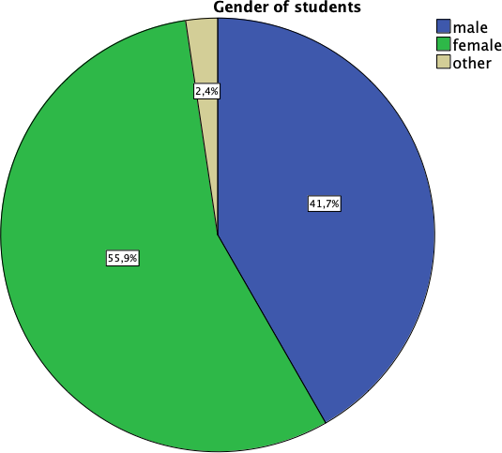

Figure 4.1.1. Descriptive statistics of gender

As shown in the chart, out of 422 subjects, people in the gender of students group are male accounting for 41.7%, female accounting for 55.9%, other accounting for 2.4%.
    - Major and courses of students

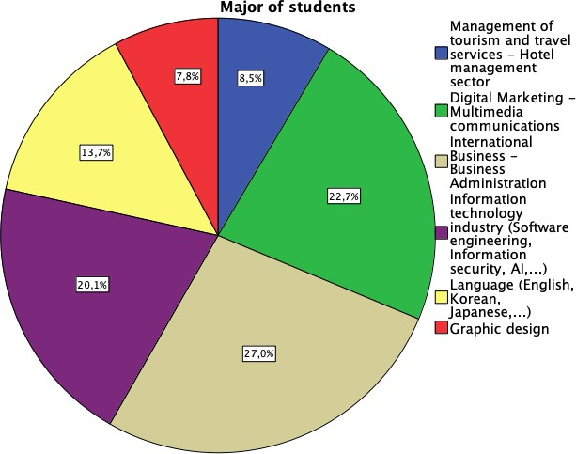
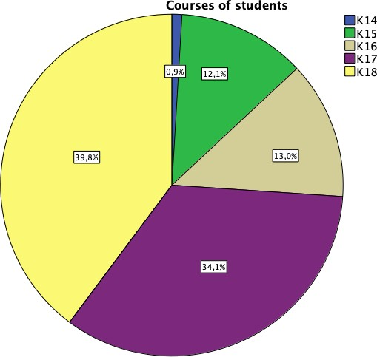

Figure 4.1.2. Descriptive statistics of major and courses
Students in the field of international Business - Business Administration accounting for the highest rate 27% but students in field graphic design accounted for the lowest rate of only 7.8%. In which, students in the group of courses are K18 accounting for the highest rate of 39.8%, K14 accounting for the lowest rate of 0.9%, remaining K15 accounting for 12.1%, K16 accounting for 13% and K17 accounting for 34.1%. Depending on the area and time of the survey, the percentage of major and courses students is not equal and the difference is large.

    - Education of father and mother
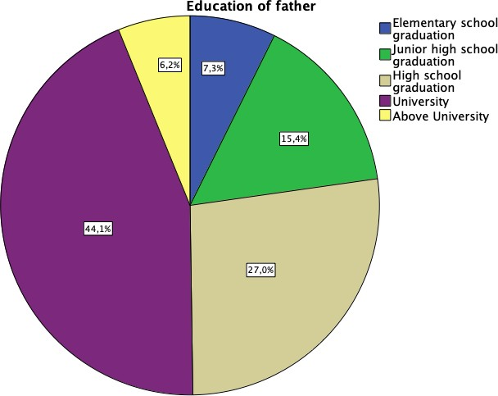
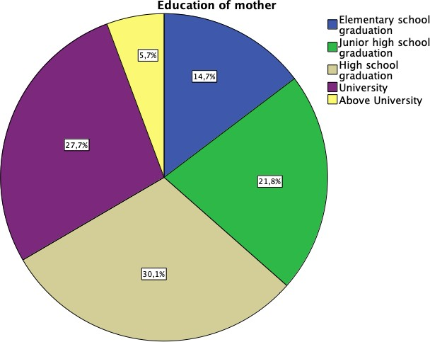

Figure 4.1.3. Descriptive statistics of education of father and mother
As shown in the chart, out of 422 subjects, education of father is elementary school graduation accounting for 7.3% and mother accounting for 14.7%, education of father is

junior high school graduation accounting for 15.4% and mother is accounting for 21.8%, education of father is high school graduation accounting for 27% and mother accounting for 30.1%, education of father is the university accounting for 44.1% and mother for 27.7%, education father is above university for 6.2% and mother for 5.7%.
    - Hometown of students
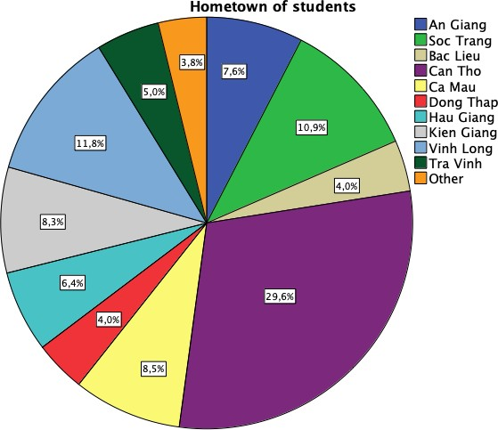

Figure 4.1.4. Descriptive statistics of hometown

As shown in the chart, out of 422 subjects, the number of students whose hometown is Can Tho accounts for the highest percentage is 29,6%, the rest are students scattered in neighboring areas with the ratio as: An Giang 7.6%, Soc Trang accounts for 10.9%, Bac Lieu accounts for 4%, Ca Mau accounts for 8.5%, Dong Thap accounts for 4%, Hau Giang accounts for 6.4%, Kien Giang accounts for 8.3%, Vinh Long accounts for 11.8%, Tra Vinh accounts for 5% and other accounts for 3.8%.
    - Occupation of father and mother
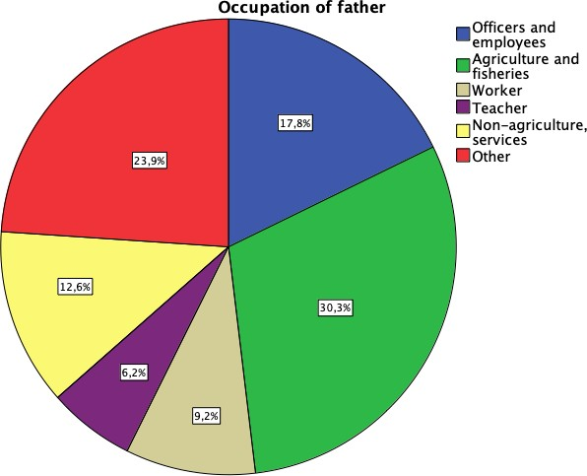
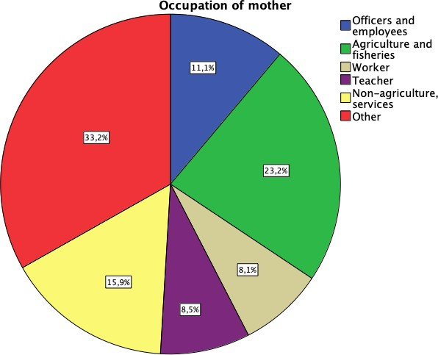

Figure 4.1.5. Descriptive statistics of occupation of father and mother
As shown in the chart, out of 422 subjects, the occupation of father group is officers and employees accounting for 17.8% and the occupation of mother accounting for 11.1%, the occupation of father group is agriculture and employees accounting for 30.3%, the occupation of mother accounting for 23.2%, the occupation of father group is the worker accounting for 9.2%, the occupation of mother accounting for 8.1%, occupation of father is teacher accounting for 6.2%, occupation of mother for 8.5%, occupation of father is non- agriculture, services accounting for 12.6%, occupation of mother accounting for 15.9%, occupation of father group is other 23.9% and occupation of mother accounting for 33.2%.
    - Average family income
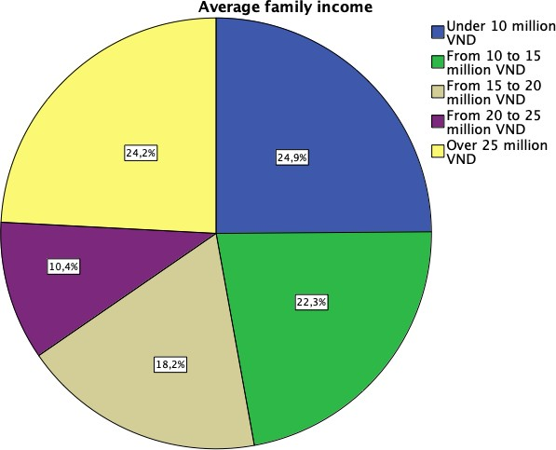

Figure 4.1.6. Descriptive statistics of average family income
As shown in the chart, out of 422 subjects, students in the average family income group are under 10 million VND accounting for 24.9%, from 10 to 15 million VND accounting for 22.3%, from 15 to 20 million VND accounting for 18.2%, from 20 to 25 million VND accounting for 10.4%, over 25 million VND accounting for 24.2%. This shows that the average family income is very positive because the percentage of families with income above 25 million VND is quite high.
    - GPA in high school

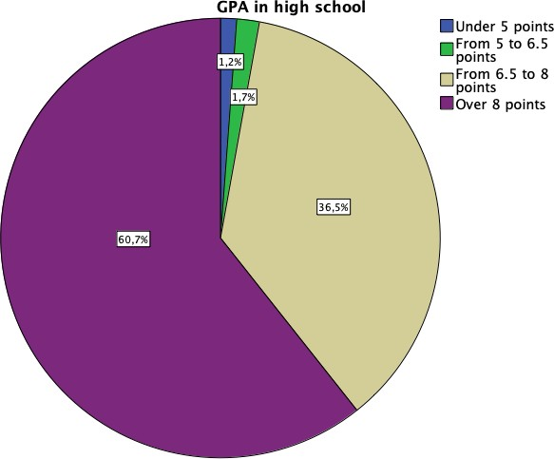

Figure 4.1.7. Descriptive statistics of GPA in high school
As shown in the chart, out of 422 subjects, the percentage of students in high school GPA group is over 8 points for 60.7%. Based on the chart above, we can see that the majority of students have high GPA in high school, indicating that students do well in high school. 4.1.8. Jobs orientation or university enrollment counseling
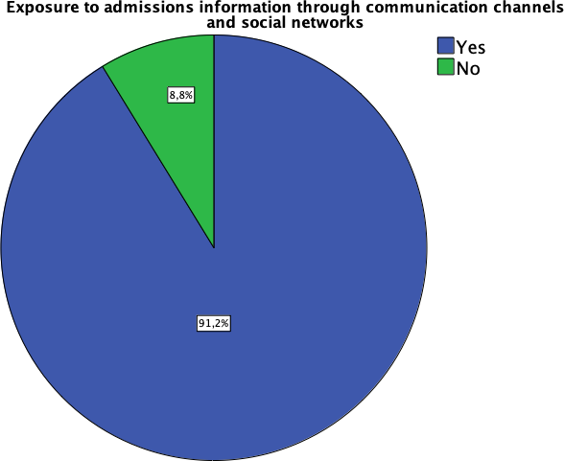
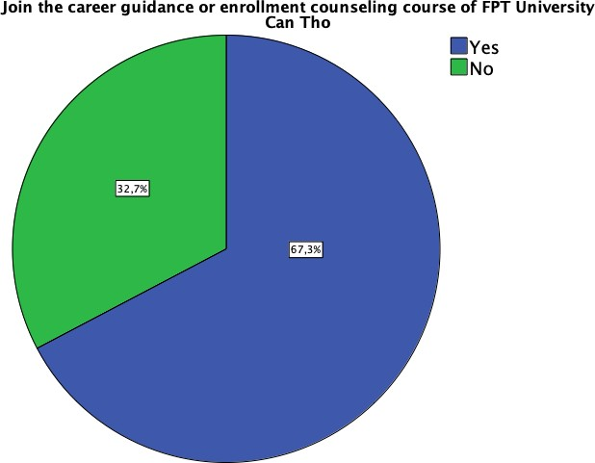

Figure 4.1.8. Descriptive statistics of jobs orientation or enrollment counseling course of FPT University Can Tho
As shown in the chart, out of 422 subjects, 284 students joined the career guidance or enrollment counseling course of FPT University Can Tho accounting for 67.3%, and the remaining of 32.7% did not join. In which, 385 students exposed to admissions information through communication channels and social networks accounting for 91.2%, and the remaining of 8.8% students did not expose. This would suggest that the university has done a great job in communication and social networking activities to easily spread it to students.
    - GPA of the most recent semester at FPT University Can Tho

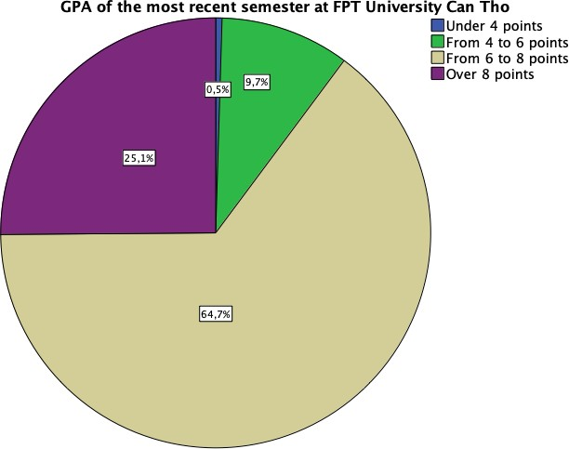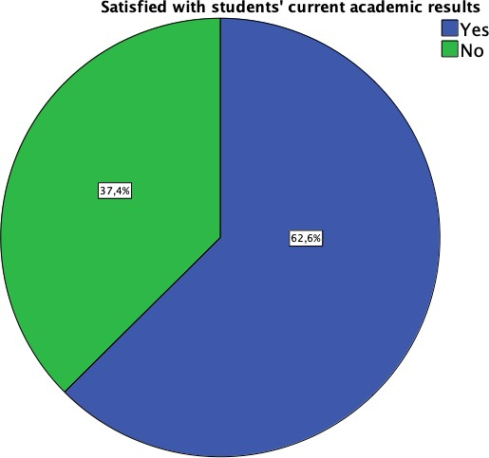

Figure 4.1.9. Descriptive statistics of GPA of the most recent semester at FPT University Can Tho
As shown in the chart, out of 422 subjects, the GPA of the most recent semester at FPT University Can Tho is under 4 points accounting for 0.5% of the total, meanwhile the proportion of students who have the GPA higher than 8 points is 25.1%. 264 students are satisfied with their current academic results accounting for 62.6% and the remaining of 37.4% are not satisfied with the results at all.
    - The family’s encouragement and teacher’s interaction

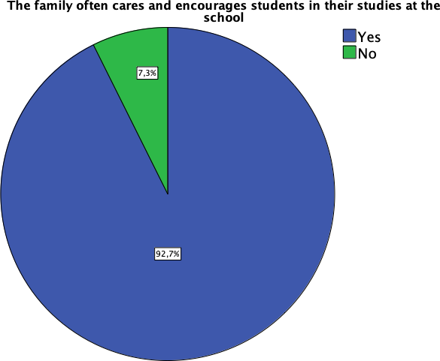
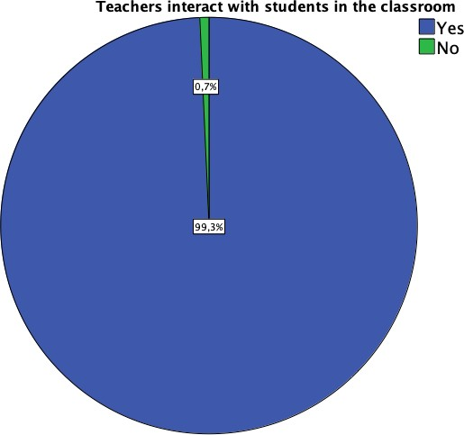

Figure 4.1.10. Descriptive statistics of the family’s encouragement and teacher’s interaction

As shown in the chart, out of 422 subjects, there are 391 students in the group of the family that often cares and encourages students in their studies at the school accounting for 92.7%, and the remaining of 7.3% are not in the group. There are 419 students in the group of teachers interacting with students in the classroom accounting for 99.3%, and the remaining

of 0.7% students are not in the group. It can be seen that teachers and families have a high level of interest and interaction with students. This will help improve achievement and help students deal with academic difficulties.
    - The support from lectures during learning process
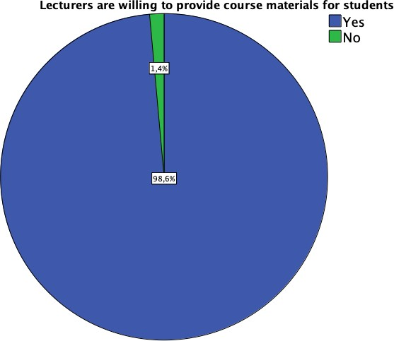
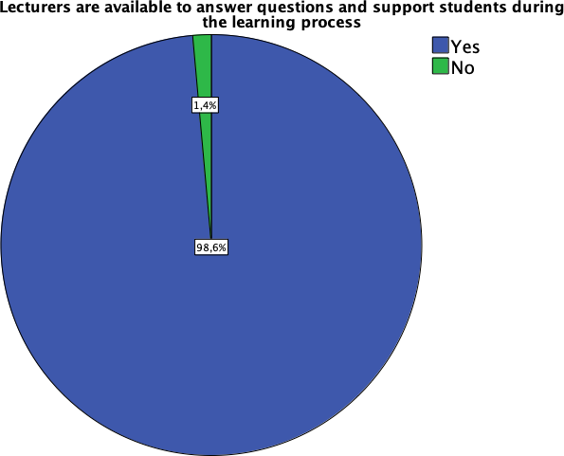

Figure 4.1.11. Descriptive statistics of the support from lectures during learning process
As shown in the chart, out of 422 subjects, there are 416 students in the group lecturers are willing to provide course materials for students accounting for 98.6%, and the remaining of 0.4% students who are not in the group. There are 416 people in the group of lecturers available to answer questions and support students during the learning process accounting for 98.6%, and the remaining of 1.4% students who are not in the group.
This would suggest that most of the teachers give great attention and support to students because the rate is very high. However, there is still a small percentage of students who do not benefit from a pool of teachers who are willing to provide materials and support, which may require teacher assessment and inquiry cause for improvement.
    - The type of English certificate and the student’s level English
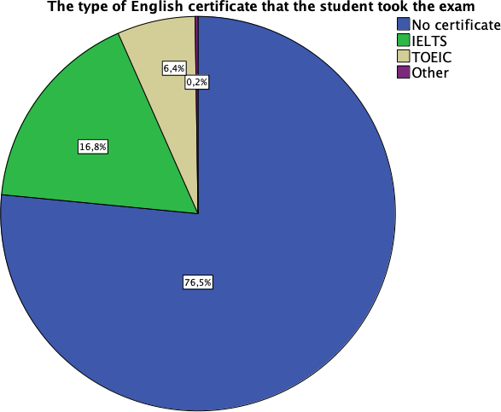
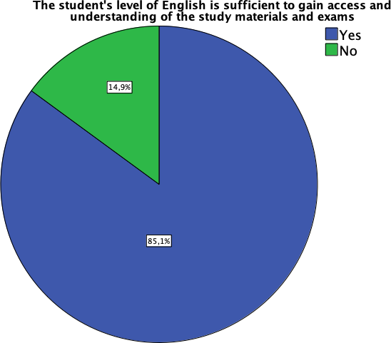

Figure 4.1.12. Descriptive statistics of the type and the level of English certificates

The percentage of students no certificate is quite high, up to 76.5%. Students with IELTS certificate accounted for 16.8%, and students with TOEIC certificate accounted for 6.4%, other certificates accounted for only 0.2%. In addition, there are 359 students in the group of the student's level of English is sufficient to gain access and understanding of the study materials and exams accounting for 85.1%, The rest, there are 14.9% students not in this group. Students who are qualified to understand and test English have a high rate, but the rate of no certificates is also high, indicating that students still need to supplement and improve their qualifications to be able to access certificates. The majority of IELTS and TOEIC certificates show that students are very focused on obtaining international English certificates.
    - Application of English skills to the learning process and exams
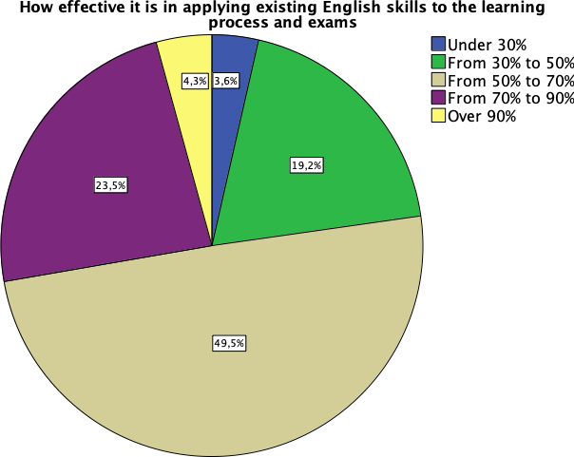

Figure 4.1.13. Descriptive statistics on the application of English skills to the learning process and exams

As shown in the chart, out of 422 subjects, the percentage of people in the group how effective it is in applying existing English skills to the learning process and exams is under 30% accounting for 3.6%, is from 30% to 50% accounting for 19.2%, is from 50% to 70%
accounting for 49, 5%, is from 70% to 90% accounting for 23.5%, is over 90% accounting
for 4.3%.
Students belong to the group with test results from 50% to 70%, accounting for a high ratio. This shows that a large part of students has applied their existing English skills to the learning process and achieved quite good results.

    - Time students spend on social networks in a day

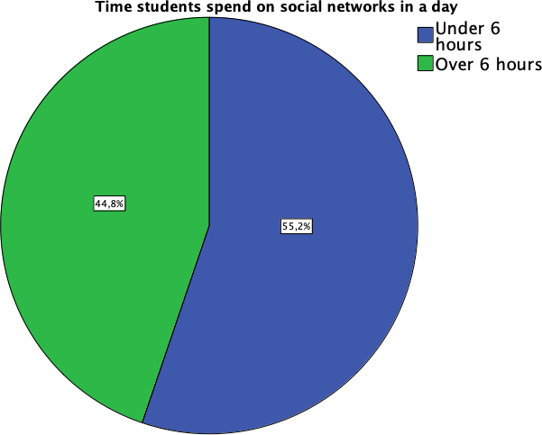

Figure 4.1.14. Descriptive statistics of time students spend on social networks in a day
As shown in the chart, out of 422 subjects, students spend time on social networks in a day are under 6 hours accounting for 55.2% and spending time over 6 hours a day accounting for 44.8%.
Time using social networks less than 6 hours a day accounts for a larger proportion than time using more than 6 hours. This shows that most students use social networks rationally and can manage their time properly so as not to affect much to other learning and living activities.
    - Social networks and communication channels commonly used by students

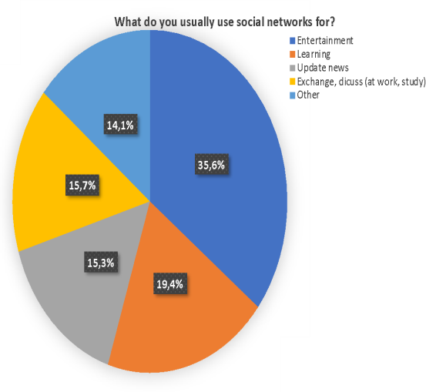
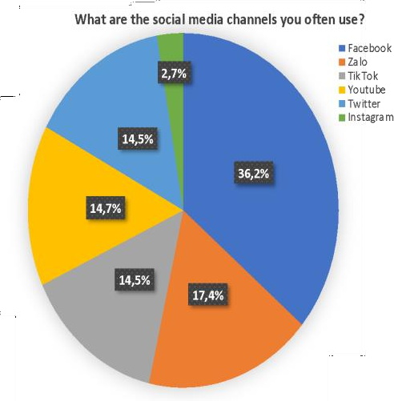

Figure 4.1.15. Descriptive statistics of social networks and communication channels commonly used by students

In 422 research subjects, students in the group usually use social networks for entertainment accounting for 35.6%, learning accounting for 19.4%, update news accounting for 15.3%, Exchange, discuss (at work, study) accounting for 15.7%, other accounting for 14.1%. In which, the social media channels often use Facebook accounting for 36.2%, Zalo accounting for 17.4%, Tiktok accounting for 14.5%, Youtube accounting for 14.7%, Twitter accounting for 14.5%, Instagram accounting for 2.7%.
The highest rate of use for entertainment purposes shows that social media helps to relax, but consideration should be given to avoiding distractions from studying.
    - Time for students to organize group study and system knowledge in a week

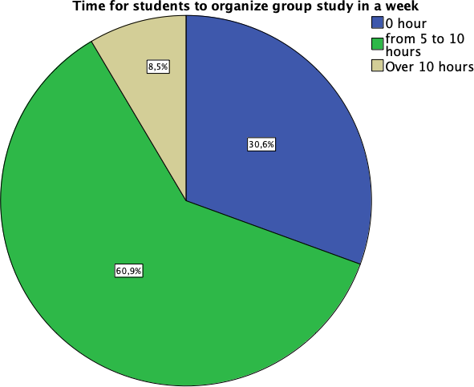
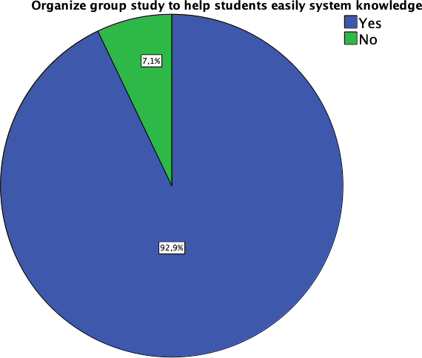

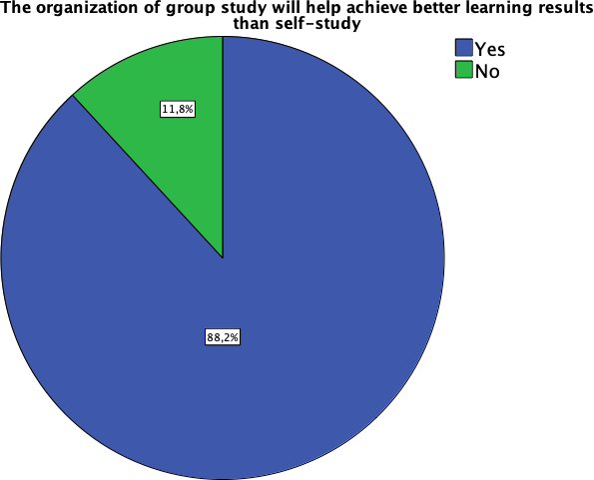

Figure 4.1.16. Descriptive statistics of time for students to organize group study and system knowledge in a week
Within the scope of the study involving 422 participants. Notably, 30.6% reported dedicating no time at all to group study in a given week, while a significant 60.9% invested

between 5 to 10 hours. A smaller cohort, comprising 8.5%, indicated a commitment exceeding 10 hours weekly.
Intriguingly, out of the total subjects, a substantial majority of 92.9% actively engaged in group study sessions, utilizing them as a means to systematically structure their knowledge. Conversely, the remaining 7.1% chose not to participate in group study endeavors.
Moreover, a noteworthy 88.2% of the respondents within the study group expressed that they employed collaborative study sessions to enhance their learning outcomes beyond what individual self-study could offer. In contrast, 11.8% opted not to partake in such group study practices.
    - Students feel pressure when their friends have better academic results
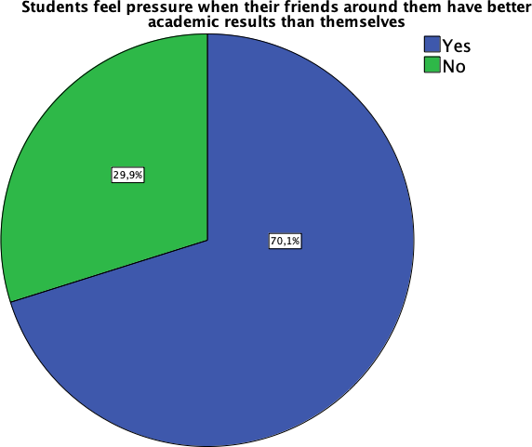
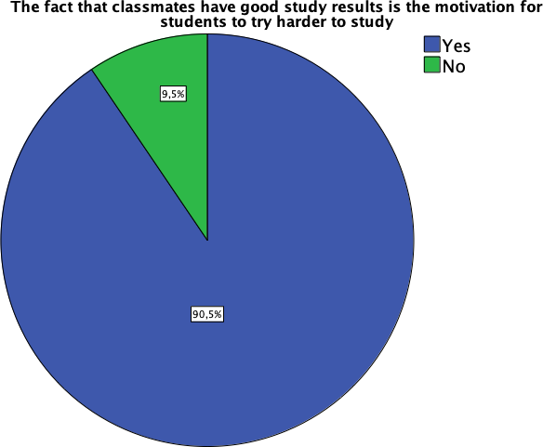

Figure 4.1.17. Descriptive statistics of student’s peer pressure
As shown in the chart, out of 422 subjects, 296 people in the group of students feel pressure when their friends around them have better academic results than themselves accounting for 70.1%, and the remaining of 29.9% are not in the group., there are 382 people in the group the fact that classmates have good study results is the motivation for students to try harder to study accounting for 90.5%, and the remaining of 9.5% are not in the group.
Students feel peer pressure is the driving force with a high percentage, showing that competitive psychology and comparison with friends can affect students' learning motivation.

Assessment of measurement scale

As mentioned in Chapter 3, each model consists of 9 independent variables and one dependent variable. To evaluate the internal consistency and unidimensionality of each

construct, reliability tests and factor analysis are conducted for individual constructs. The reliability test is carried out when the assumption of unidimensionality is justified (Hair et al., 1998). Thus, before testing the reliability of the measurement scale, an assessment of the measurement scale's unidimensionality is performed.
The process of assessing and refining the measurement scale is executed in two steps using SPSS 25.0 software. The first step involves conducting Exploratory Factor Analysis (EFA) and calculating Cronbach's alpha to evaluate unidimensionality and reliability, respectively. In the second step, EFA is performed with all scales together to assess convergent validity and discriminant validity. During this process, items that fail to meet the evaluation criteria are removed. Following the refinement, the scale's reliability is re- evaluated using Cronbach's alpha. The criteria for item refinement include factor loading > 0.40, item-total correlation > 0.3, Cronbach's alpha > 0.60, and a percentage of variance (Hair et al., 1998).

Testing reliability of scales
Prior to conducting Exploratory Factor Analysis (EFA), the research team assessed the reliability of the measurement items related to the factors influencing the academic performance of FPT Can Tho University students using Cronbach's Alpha testing. The team set the minimum Cronbach's Alpha coefficient at 0.6, and it was required that the Corrected Item-Total Correlation be greater than 0.3 (Hair et al., 1998).
The results of the reliability testing indicated that all measurement scales for the factors affecting academic performance, such as family, teacher competence, students themselves, English level, use of social networks, part-time job, joining the club, learning group, peer pressure, health, and infrastructure, met the reliability requirements (minimum Cronbach's Alpha > 0.6). Consequently, these scales were included in the subsequent Exploratory Factor Analysis (EFA). The measurement scale for the level of academic performance also exhibited satisfactory reliability with a Corrected Item-Total Correlation > 0.3 and a Cronbach's Alpha of 0.916, meeting the reliability requirement (minimum Cronbach's Alpha
> 0.6). Overall, the measurement scale for the factors influencing the academic performance of FPT university students comprised 9 component factors with 35 variables, alongside GPA scores with 4 variables. The examination results are presented in the table below.
Table 4.1: Cronbach’s Alpha test results

Construct  /Items | Item | Description | Corrected item-total correlation
FAMILY  (Alpha =0.862) | FA1 | My family is a solid fulcrum for me to strive for in my studies | 0.739
 | FA2 | The interest and encouragement from the family has a POSITIVE impact on the student's academic performance | 0.747
 | FA3 | Families with good economic conditions help students feel secure and have good academic performance | 0.683
 | FA4 | Families with good economic conditions help students feel secure and have good academic performance | 0.683
TEACHER COMPETENC E  (Alpha =0.909) | TC1 | Teachers with good teaching ability help students achieve good academic performance | 0.818
 | TC2 | The effective teaching method of the lecturer helps you achieve a good academic performance | 0.835
 | TC3 | The professional knowledge of the lecturer helps you to easily systemize your knowledge and achieve a good academic performance | 0.720
 | TC4 | The teacher's dedication in teaching helps students achieve a good academic performance | 0.806
ENGLISH LEVEL  (Alpha =0.904) | EL1 | If the student's English level is good, the student's academic performance will also be good | 0.787
 | EL2 | A good student's English level will help students easily master the knowledge and easily understand the lesson | 0.820
 | EL3 | A good student's English level enables them to refer to many valuable resources | 0.774
 | EL4 | A good student's English level helps them to easily read and understand the topics and pass the school's FINAL exams | 0.759
USE SOCIAL NETWORKS  (Alpha =0.876) | SN1 | Spending a lot of time on social networks will distract from learning | 0.759
 | SN2 | The spread of unverified information on social networks will negatively affect the learning spirit | 0.772

 | SN3 | Spending a lot of time using social networks will have a NEGATIVE impact on students' academic performance | 0.740
 | SN4 | IF students use social networks incorrectly and for the wrong purposes, it will have a NEGATIVE impact on students' academic performance | 0.667
PART-TIME JOB  (Alpha =0.935) | PJ1 | Students who spend a lot of time on part-time jobs will distract from the main study at school | 0.864
 | PJ2 | Students who spend a lot of time on part-time jobs will not be able to guarantee their schedule | 0.871
 | PJ3 | Students who spend a lot of time on part-time jobs will reduce self-study time | 0.816
 | PJ4 | Students spending a lot of time on Part-time jobs will have a NEGATIVE impact on academic performance | 0.838
JOINING THE CLUB  (Alpha =0.940) | CLUB 1 | Students who spend a lot of time on Joining the club will distract from the main study at school | 0.860
 | CLUB 2 | Students who spend a lot of time on Joining the club will not guarantee the class schedule | 0.877
 | CLUB 3 | Students spend more time on Joining the club will reduce self-study time | 0.836
 | CLUB 4 | Students who spend a lot of time on Joining the club will have a NEGATIVE impact on academic performance | 0.857
LEARNING GROUPS  (Alpha =0.923) | LG1 | Study groups help improve student learning performance | 0.817
 | LG2 | Study groups will make it easier for students to understand the lesson | 0.835
 | LG3 | Study groups will help students have a more multi- dimensional perspective on issues in lessons and research papers | 0.805
 | LG4 | Study groups has a POSITIVE impact on your academic performance | 0.826

PEER PRESSURE  (Alpha =0.889) | PP1 | Pressure from peers/peer pressure will motivate students to try harder in their studies | 0.800
 | PP2 | Pressure from friends around / peer pressure will help students be more excited in active learning | 0.796
 | PP3 | I will turn pressure into motivation for myself to be more breakthrough in studying | 0.754
INFRASTRUC  TURE (Alpha = 0.916) | INFR A1 | Adequate and high-quality infrastructure inside the classroom will help students achieve a good academic performance | 0.819
 | INFR A2 | The quality of the school's electricity, water and sanitation systems will help students achieve a good academic performance | 0.822
 | INFR A3 | The school's high-quality Internet system will help students easily access learning resources and achieve good academic performance | 0.781
 | INFR A4 | A high level of student satisfaction with Infrastructure will have a POSITIVE impact on student academic performance | 0.814
ACADEMIC PERFORMAN  CE (Alpha = 0.884) | AP1 | I think my current study results are in line with my ability | 0.682
 | AP2 | I have developed a lot of knowledge and skills in my subjects | 0.803
 | AP3 | I can put the knowledge I have learned into practice after graduation | 0.737
 | AP4 | Overall, I have learned a lot of knowledge and skills in studying | 0.776

Exploratory Factor Analysis (EFA)

      - EFA for all scale of antecedent factors

Once the unidimensionality and reliability of each measurement scale were established, all 39 variables representing 9 factors were included in the exploratory factor analysis (EFA). During the EFA process, variables that exhibited high loadings on more than two factors were eliminated, while those with factor loadings below 0.50 were excluded. Retention criteria included a variance percentage above 50% and an eigenvalue above 1.

The Kaiser-Meyer-Olkin (KMO) measure, which fell within the range of 0.5 to 1 (0.5
< KMO < 1), indicated the suitability of the data for factor analysis. Additionally, Bartlett's Test of Sphericity yielded a significance level of ≤ 0.05, suggesting statistical significance (Nguyen, 2001, citing Al Jabnoun & Tamimi, 2003).

Following the exploratory EFA analysis, the research team retained seven factors comprising 35 variables, which accounted for 75.601% of the total variance, with an initial eigenvalue of 1.029. The factor loadings of the 35 variables ranged from 0.562 to 0.879, all exceeding 0.50 (Table 4.4). The results of Bartlett's Test of Sphericity and the Kaiser-Meyer- Olkin measure demonstrated an appropriate correlation level among variables for EFA, as presented in Table 4.2 (KMO = 0.943; Chi-square = 13183.380; df = 595, Sig = 0.000).
Table 4.2: KMO and Bartlett's Test

Kaiser-Meyer-Olkin Measure of Sampling Adequacy. |  | .943
Bartlett's Test of Sphericity | Approx. Chi-Square | 13183.380
 | df | 595
 | Sig. | .000
Extraction Method: Principal Component Analysis.

Table 4.3: Total Variance Explained

Com pone  nt | Initial Eigenvalues |  |  | Extraction Sums of Squared Loadings |  |  | Rotation Sums of Squared Loadings
 | Total | % of  Variance | Cumulat  ive % | Total | % of  Variance | Cumulative  % | Total | % of  Variance | Cumulativ  e %
1 | 15.723 | 44.922 | 44.922 | 15.723 | 44.922 | 44.922 | 6.120 | 17.485 | 17.485
2 | 4.167 | 11.906 | 56.828 | 4.167 | 11.906 | 56.828 | 5.084 | 14.526 | 32.011
3 | 1.823 | 5.210 | 62.038 | 1.823 | 5.210 | 62.038 | 3.475 | 9.930 | 41.940
4 | 1.339 | 3.825 | 65.863 | 1.339 | 3.825 | 65.863 | 3.326 | 9.502 | 51.442
5 | 1.197 | 3.419 | 69.282 | 1.197 | 3.419 | 69.282 | 3.282 | 9.376 | 60.819
6 | 1.183 | 3.379 | 72.661 | 1.183 | 3.379 | 72.661 | 2.901 | 8.290 | 69.108
7 | 1.029 | 2.941 | 75.601 | 1.029 | 2.941 | 75.601 | 2.273 | 6.493 | 75.601
Extraction Method: Principal Component Analysis.

Table 4.4: Rotated Component Matrix (a)

 | Component
 | 1 | 2 | 3 | 4 | 5 | 6 | 7
CLUB2 | .879
CLUB4 | .873
CLUB1 | .856
CLUB3 | .823
PJ4 | .730
PJ2 | .682
PJ1 | .623
PJ3 | .606
TC4 |  | .804
TC1 |  | .791
TC2 |  | .782
TC3 |  | .702
EL3 |  | .670
EL1 |  | .604
EL4 |  | .603
EL2 |  | .562
SN2 |  |  | .732
SN4 |  |  | .662
SN1 |  |  | .621
SN3 |  |  | .619
INFRA3 |  |  |  | .777
INFRA4 |  |  |  | .774
INFRA2 |  |  |  | .765
INFRA1 |  |  |  | .754
LG2 |  |  |  |  | .737
LG1 |  |  |  |  | .715
LG4 |  |  |  |  | .712
LG3 |  |  |  |  | .686
FA1 |  |  |  |  |  | .794
FA2 |  |  |  |  |  | .758
FA4 |  |  |  |  |  | .676
FA3 |  |  |  |  |  | .667
PP3 |  |  |  |  |  |  | .711
PP2 |  |  |  |  |  |  | .707
PP1 |  |  |  |  |  |  | .701
Extraction Method: Principal Component Analysis. Rotation Method: Varimax with Kaiser Normalization.
a. Rotation converged in 10 iterations.

EFA for academic performance (AP)

The results of the factor analysis with the academic performance of FPT Can Tho University students (AP) are presented in Table 4.6. In this analysis, three variables were retained together, explaining 76.443% of the total variance, with an initial eigenvalue of

2.293. The factor loadings of these three variables ranged from 0.858 to 0.896, all exceeding
0.40 (Table 4.6). The results of Bartlett's Test of Sphericity and the Kaiser-Meyer-Olkin measure indicated the appropriate correlation level among variables for the EFA procedure, as shown in Table 4.5 (KMO = 0.721; Chi-square = 253.390; df = 3, Sig = 0.000).
Table 4.5: Result of EFA with academic performance (AP) KMO and Bartlett's Test (AP)
Kaiser-Meyer-Olkin Measure of Sampling Adequacy. |  | .811
Bartlett's Test of Sphericity | Approx. Chi-Square | 958.854
 | df | 6
 | Sig. | .000

Total Variance Explained

Component | Initial Eigenvalues |  |  | Extraction Sums of Squared Loadings
 | Total | % of  Variance | Cumulative  % | Total | % of  Variance | Cumulative  %
1 | 2.984 | 74.596 | 74.596 | 2.984 | 74.596 | 74.596
2 | .446 | 11.152 | 85.747
3 | .357 | 8.915 | 94.663
4 | .213 | 5.337 | 100.000
Extraction Method: Principal Component Analysis.

Component Matrix(a)

 | Component 1
AP2 | .898
AP4 | .884
AP3 | .854
AP1 | .815
Extraction Method: Principal Component Analysis.a. 1 components extracted.

The results of the unidimensionality and reliability testing of the measurement scale are summarized in the following table:
Table 4.6: Summary results of testing scales

Factors | Items | Cronbach  Alpha | % of  Variance | Assessment
Family (FA) | 4 | 0.862 | 75.601 | satisfied
Teacher competence (TC) | 4 | 0.909
Infrastructure (INFRA) | 4 | 0.916
English level (EL) | 4 | 0.904
Use social networks (SN) | 4 | 0.876
Part-time job (PJ) | 4 | 0.935
Joining the club (CLUB) | 4 | 0.940
Learning group (LG) | 4 | 0.923
Peer Pressure (PP) | 3 | 0.889
Academic performance (AP) | 4 | 0.884 | 74.596 | satisfied

Revising the research model
After the exploratory factor analysis, the measurement scales were recoded and included:

 | Construct | Merge Construct | Measurement scale
1 | Part-time job (PJ) | X1_ OUTDOOR ACTIVITIES | PJ1, PJ2, PJ3, PJ4
2 | Joining the club (CLUB) |  | CLUB1, CLUB2,  CLUB3, CLUB4
3 | Teacher competence (TC) | X2_ PROFESSIONAL SUPPORT | TC1, TC2, TC3, TC4
4 | English level (EL) |  | EL1, EL2, EL3, EL4
5 | Use social networks (SN) | X3_ SOCIAL NETWORK | SN1, SN2, SN3, SN4
6 | Infrastructure (INFRA) | X4_ INFRASTRUCTURE | INFRA1, INFRA2,  INFRA3, INFRA4
7 | Learning in groups (LG) | X5_ COOPERATION | LG1, LG2, LG3, LG4
8 | Family (FA) | X6_ FAMILY SUPPORT | FA1, FA2, FA3, FA4
9 | Peer pressure (PP) | X7_ PEER PRESSURE | PP1, PP2, PP3

Outdoor activities
Professional support
Social network
Infrastructure
Academic
performance
Cooperation
Family support
Peer pressure

Figure 12: The research model is revised
Figure 5 illustrates the revised research model. The proposed research hypotheses: Hypothesis 1: There is a negative impact of outdoor activity on job academic performance. Hypothesis 2: There is a positive impact of professional support on academic performance.
Hypothesis 3: There is a negative impact of social networks on academic performance.

Hypothesis 4: There is a positive impact of infrastructure on academic performance.
Hypothesis 5: There is a positive impact of cooperation on academic performance. Hypothesis 6: There is a positive impact of family support on academic performance. Hypothesis 7: There is a positive impact of peer pressure on academic performance.

Testing model and hypotheses

Testing model
The results of the regression analysis were used to test the research hypotheses. Before conducting linear regression analysis, we examined the linear correlation between the independent and dependent variables, as well as the overall relationships between each independent variable and the dependent variable, and among the independent variables themselves.
Table 4.7: Correlations (a)

 |  | AP | X1 | X2 | X3 | X4 | X5 | X6 | X7
Pearson Correlatio n | AP | 1.000 | 0.415 | 0.538 | 0.451 | 0.469 | 0.587 | 0.565 | 0.471
 | X1 | 0.415 | 1.000 | 0.368 | 0.673 | 0.446 | 0.581 | 0.409 | 0.601
 | X2 | 0.538 | 0.368 | 1.000 | 0.541 | 0.631 | 0.615 | 0.678 | 0.495
 | X3 | 0.451 | 0.673 | 0.541 | 1.000 | 0.460 | 0.537 | 0.494 | 0.588
 | X4 | 0.469 | 0.446 | 0.631 | 0.460 | 1.000 | 0.625 | 0.529 | 0.528
 | X5 | 0.587 | 0.581 | 0.615 | 0.537 | 0.625 | 1.000 | 0.530 | 0.610
 | X6 | 0.565 | 0.409 | 0.678 | 0.494 | 0.529 | 0.530 | 1.000 | 0.448
 | X7 | 0.471 | 0.601 | 0.495 | 0.588 | 0.528 | 0.610 | 0.448 | 1.000
Correlation is significant at the 0.01 level (2-tailed).

a. List wise N=422

Based on the modified model, the following function was established to illustrate the relationship between the independent variables and the academic performance outcomes of FPT Can Tho University students. The results of the regression analysis are presented in the following tables:

Table 4.8: Model Summary (b)

Model | R | R  Square | Adjusted R Square | Std. Error of the Estimate
1 | .672(a) | .451 | .442 | .74695087
- Predictors: (Constant), Peer pressure, Family support, Cooperation, Infrastructure, Social network, Professional support, Outdoor activities
- Dependent Variable: Academic performance

The Model Summary table provides us with the results of R Square and Adjusted R Square to evaluate the goodness of fit of the model. The adjusted R Square value of 0.442 indicates that the independent variables included in the regression analysis account for 44.2% of the variance in the dependent variable. The remaining 55.8% is attributed to external variables and random error.
Table 4.9: ANOVA (b)

Model |  | Sum of Squares | df | Mean Square | F | Sig.
1 | Regression | 190.015 | 7 | 27.145 | 48.652 | .000(b)
 | Residual | 230.985 | 414 | .558
 | Total | 421.000 | 421
- Dependent Variable: Academic performance

- Predictors: (Constant), Peer pressure, Family support, Cooperation, Infrastructure, Social network, Professional support, Outdoor activities
The ANOVA table provides the results of the F-test to evaluate the hypothesis of model adequacy in regression analysis. The significance value (sig) of the F-test is 0.000, which is less than 0.05. Therefore, the regression model is deemed to be statistically significant and appropriate.

Table 4.10: Coefficients (a)

Coefficients
Model |  | Unstandardized  Coefficients |  | Standardized  Coefficients | t | Sig. | Collinearity Statistics
 |  | B | Std.  Error | Beta |  |  | Tolerance | VIF
1 | (Constant) | 2,376E-16 | ,036 |  | ,000 | 1,000
 | Outdoor  activities | ,233 | ,036 | ,233 | 6,403 | ,000 | 1,000 | 1,000
 | Professional  support | ,297 | ,036 | ,297 | 8,148 | ,000 | 1,000 | 1,000
 | Social network | ,120 | ,036 | ,120 | 3,287 | ,001 | 1,000 | 1,000
 | Infrastructure | ,185 | ,036 | ,185 | 5,088 | ,000 | 1,000 | 1,000
 | Cooperation | ,313 | ,036 | ,313 | 8,594 | ,000 | 1,000 | 1,000
 | Family  support | ,344 | ,036 | ,344 | 9,462 | ,000 | 1,000 | 1,000
 | Peer pressure | ,209 | ,036 | ,209 | 5,752 | ,000 | 1,000 | 1,000
a. Dependent Variable: Academic performance

The Coefficients table provides the results of the t-test to assess the significance of the regression coefficients, the VIF (Variance Inflation Factor) to evaluate multicollinearity, and the regression coefficients themselves. The variables Outdoor activities, Professional support, Social network, Infrastructure, Cooperation, Family support, and Peer pressure all have t-test significance values (sig) less than 0.05. Therefore, these variables are statistically significant and have an impact on the dependent variable, Academic performance. The regression coefficients of these independent variables are all positive, indicating that they have a positive influence on the dependent variable.

Based on the results in Table 4.10, the regression equation with standardized coefficients can be established as follows:

Academic Performance = 2,376E-16 + 0.344 * Family support + 0.313 * Cooperation + 0.297
* Professional support + 0.233 * Outdoor activities + 0.209 * Peer pressure + 0.185 * Infrastructure + 0.120 * Social network (4.1)

Testing hypotheses

The standardized regression coefficients obtained from the model are used to test the hypotheses presented in section 4.2.3. As shown in Table 4.11, detailed explanations of the testing results for each hypothesis among the seven hypotheses are presented below.

Table 4.11: Regression coefficients

Hypotheses | Relationship | Standardized coefficient Beta | Sig. | Testing hypotheses
H1 | Outdoor activities AP | 0.233 | 0.000 | is not  supported
H2 | Professional support AP | 0.297 | 0.000 | is supported
H3 | Social network AP | 0.120 | 0.001 | is not  supported
H4 | Infrastructure AP | 0.185 | 0.000 | is supported
H5 | Cooperation AP | 0.313 | 0.000 | is supported
H6 | Family support AP | 0.344 | 0.000 | is supported
H7 | Peer pressure AP | 0.209 | 0.000 | is supported

The standardized regression coefficient of family support on Academic Performance (AP) is 0.344 (sig. = 0.000 < 0.05). This means that family support has a positive impact on the academic performance of FPT Can Tho University students. The standardized regression coefficient of Family support (β = 0.344) at sig. = 0.000 indicates that when Family support increases, the GPA of FPT Can Tho University students increases by approximately 0.344 units when the other variables remain constant. Financial support from the family can help reduce the pressure on students, allowing them to focus more on their studies and participate in relevant extracurricular activities. The family plays an important role in providing emotional support and encouragement to students. Encouragement, care, and trust from the family can create a positive environment and motivation for students. This can help students become more confident, face academic challenges, and achieve success. Therefore, FPT Can Tho University is always concerned about connecting parents with students, ensuring transparency in the educational process for both parents and students when necessary. This builds trust among parents, enabling them to feel reassured about their children's education at the university.

The standardized regression coefficient of cooperation on Academic Performance (AP) is 0.313 (sig. = 0.000 < 0.05). This means that cooperation has a significantly positive effect on the learning process and personal development of students. Therefore, cooperation is a factor that positively influences the academic performance of FPT Can Tho University students. The standardized regression coefficient of Cooperation (β = 0.313) at sig. = 0.000 indicates that when cooperation increases by one unit, the GPA of FPT Can Tho University students increases by approximately 0.313 units when the other variables remain constant. When participating in group study sessions, students have the opportunity to access different perspectives and solutions from other group members. Through discussion and exchange, students can gain new insights, explanations, and clearer directions regarding the study material. Moreover, students have the opportunity to share difficulties, discuss, and seek solutions together. The support and exchange of ideas from other group members can help address challenges and difficulties in the learning process. Additionally, group study encourages bonding and interaction among group members. During group work, students must take responsibility and complete their tasks on time. Commitment and responsibility to the group help students maintain focus, positivity, and goal-oriented learning. However, it is important to note that the impact of group study on GPA may depend on the level of commitment and positive interaction within the group. To make group study effective and contribute to improving GPA, students need to actively participate, share, and benefit from the support and knowledge exchange within the group.
The standardized regression coefficient of professional support on Academic Performance (AP) is 0.297 (sig. = 0.000 < 0.05). This means that professional support has a positive impact on the academic performance of FPT Can Tho University students. Professional support also strongly supports the overall literature discussed in Chapter 2 regarding the factors influencing the academic performance of FPT Can Tho University students. The standardized regression coefficient of Professional support (β = 0.297) at sig.
= 0.000 indicates that when professional support increases by one unit, the academic performance of FPT Can Tho University students increases by approximately 0.297 units when the other variables remain constant. Professional support consists of two factors: English proficiency and faculty competence. These are considered important factors that influence the academic performance of students. With the English-medium program at FPT Can Tho University, students with higher English proficiency can grasp lectures faster and access additional reference materials more efficiently than other students. The faculty at FPT

Can Tho University is evaluated as having high professional expertise and a dedicated teaching approach. The instructors here are attentive, caring, and create a comfortable learning environment for students to achieve effective academic performance.
The standardized regression coefficient of outdoor activities on Academic Performance (AP) is 0.233 (sig. = 0.000 < 0.05). This means that outdoor activities have a positive impact on the academic performance of FPT Can Tho University students. In this case, the outdoor activities at FPT University Can Tho are mainly designed for students in collaborating with academic knowledge in class. Hence, although spending time for other activities, students can also achieve good final results since they can learn more practical experience with the workshops or marketing campaigns at university. The suggestion for better results is that students need to prioritize allocating their time and maintaining a proper balance of physical and mental health to have the best experiences while still achieving high academic results. Additionally, the university should consider developing well-structured experiential activities that provide a clear orientation towards the importance of studying and help students balance their extracurricular activities. When students achieve a balance between extracurricular activities and academics, it will lead to better academic performance. As a result, the reputation and credibility of the university will be enhanced.
The standardized regression coefficient of peer pressure on Academic Performance (AP) is 0.209 (sig. = 0.000 < 0.05). This means that peer pressure has a positive impact on the academic performance of FPT Can Tho University students. Friends can influence the study habits of students. If students have friends who are serious and diligent in their studies, they can be inspired to work hard and pursue academic goals. However, if students have friends who do not prioritize studying and focus on unrelated activities, it can affect their motivation and concentration. Friends can encourage students to improve their academic performance through competition in grades or academic achievements. However, excessive or unhealthy competition can create unnecessary pressure and stress for students. Additionally, friends can influence students' lives outside of their studies, such as encouraging participation in social, cultural, or sports activities. A positive and supportive peer environment can provide balance and help students develop social skills, create diverse experiences, and provide motivation for the learning process. It is important to have the ability to recognize and select positive influences from friends while maintaining focus and commitment to academic study.

The standardized regression coefficient of infrastructure on Academic Performance (AP) is 0.185 (sig. = 0.000 < 0.05). This means that Infrastructure plays an essential role in building the quality of students learning results. The university is a place where crucial teaching, research, and knowledge exchange activities take place, and having good infrastructure is vital to ensure the effectiveness of these activities. Infrastructure is a factor that positively influences the academic performance of FPT Can Tho University students. The standardized regression coefficient of Infrastructure (β = 0.185) at sig. = 0.000 indicates that when infrastructure increases by one unit, the GPA of FPT Can Tho University students increases by approximately 0.185 unit when the other variables remain constant. The infrastructure at the university is important as it provides favorable conditions for learning and research activities, meets spatial requirements, supports students and faculty, creates a safe environment, and attracts talent. For a quality university, investing in and maintaining infrastructure is essential. FPT Can Tho University places great emphasis on investing in and continuously improving infrastructure to serve the teaching and learning activities of its faculty and students.
The standardized regression coefficient of social network on Academic Performance (AP) is 0.120 (sig. = 0.001 < 0.05). This means that social network is also a factor that positively affects the academic performance of FPT Can Tho University students. When social networks increase by one unit, the GPA of FPT Can Tho University students could increase by approximately 0.120 unit when the other variables remain constant. As described in the descriptive statistics section, students at FPT Can Tho uses social network mainly for learning and updating news purpose. This is considered as an effective channel of learning the new things and innovative solutions for studying process. Therefore, FPT Can Tho University students need to pay attention to how they use social networks to ensure they can balance entertainment and relaxation while not compromising their academic performance. Additionally, the university should consider developing well-structured experiential activities that provide a clear orientation on the proper use of social media because when students achieve a balance between social network usage and academics, it will lead to better academic performance. As a result, the reputation and credibility of the university will be enhanced.

Summary of the chapter

In this chapter, the research findings have been presented, and the measurement scales were subjected to rigorous evaluation for unidimensionality, reliability, and validity using Cronbach's alpha and exploratory factor analysis. The results obtained from our study reveal the presence of 5 factors that have positive effects, namely professional support, infrastructure, cooperation, family support, and peer pressure, as well as 2 factors with negative effects, which are outdoor activities and social network. As a result, hypotheses H1, H2, H3, H4, H5, and H6 are supported.
Chapter 5 will delve into a comprehensive discussion of the acquired findings and will also shed light on other pertinent studies conducted in this field that align with our emerged results. Lastly, the chapter will draw conclusions based on the findings and provide valuable recommendations for future endeavors.

CHAPTER 5

CONCLUSION, LIMITATIONS, IMPLICATIONS AND RECOMMENDATIONS
This chapter is the final chapter of the research work on this topic. This chapter includes Conclusions, Limitations and Recommendations for further research. In the Conclusion section, the results will be reported on which factors have affected the student's academic performance and propose recommendations to improve the student's academic performance. The Limitations section will show the limitations that the research topic is facing. And finally, the Recommendations for Further Research section offers specific recommendations for future research should they continue to work on the topic.

Conclusion
This research aims to identify the factors and their impact on the academic performance of students at FPT University in Can Tho. The initial proposed research model consisted of 1 dependent variable and 9 independent variables with 9 hypotheses. After conducting Exploratory Factor Analysis (EFA) and regression analysis, the final adjusted research model includes 7 factors and 7 hypotheses that influence academic performance, which are:
(1) Outdoor activities, (2) Professional support, (3) Social networks, (4) Infrastructure, (5) Cooperation, (6) Family support, and (7) Peer pressure.
The research results have helped validate the proposed assumptions. However, it is evident that academic performance depends on various other factors, and adjustments to concepts and measurements are necessary to suit the specific conditions of each educational institution. Studying the influencing factors on academic performance aids in identifying solutions and methods to enhance students' learning effectiveness. Understanding which factors can affect academic performance helps students realize and implement changes and improvements in their learning process. Furthermore, this research supports administrators, teachers, and parents in understanding the factors influencing students' academic performance, enabling them to devise solutions to improve the quality of teaching and learning, ultimately enhancing the quality of higher education.
Based on the analysis of the obtained results, the research team proposes some recommendations to further improve students' academic performance.

Recommendations
    - Strengthening the Family-School Connection
From the research results, it is evident that "family support" has the strongest impact on students' academic performance, highlighting the importance of family influence on student learning. Parents should take a more active role in their child's education by monitoring their studies, engaging in regular conversations about their progress, test results, assignments, and projects. This helps parents understand the difficulties their children may face and provide appropriate support. Parents should also proactively connect with teachers and the school to enhance support and contribute to their children's academic success. The school should provide more support to parents in monitoring students' learning progress, allowing parents to assist students in completing assignments at home, providing feedback, and engaging in ongoing communication with teachers to achieve better results.
    - Enhancing teacher - Student Interaction
Regular interaction between students and teacher both inside and outside the classroom is crucial in motivating and engaging students in their learning process. Teacher should possess certain skills to attract students' attention and foster active participation in learning. Addressing students by their names and creating a friendly learning environment can be beneficial. Instead of delivering monotonous lectures, teacher can incorporate creative and interactive elements to make the learning experience more enjoyable and comprehensible for students. Additionally, teacher should actively listen to students' opinions and viewpoints, making them feel valued and respected.
The school can also support teacher in connecting with students by creating a close-knit learning environment. Designing study areas or small classrooms where students can comfortably meet and converse with teacher outside of formal class hour fosters communication and information exchange beyond regular lectures.
Organizing extracurricular activities can be beneficial, such as sports events, competitions, travel opportunities, or social gatherings through academic and cultural clubs. These activities will help create a friendly and cohesive bond between teacher and students outside the primary learning environment.
FPT University has already done well in building a feedback system, including post-course surveys, teaching evaluations, and online feedback mechanisms. By receiving feedback, teacher can identify their strengths and weaknesses and adjust their teaching methods for better effectiveness.

Promoting positive contests in an academic setting enhances peer pressure without fostering unhealthy competition among students. These contests motivate students to strive for excellence, emphasizing personal growth and collaboration. By focusing on academic achievements, students develop a positive attitude towards learning and are intrinsically motivated to succeed.

Limitations
After conducting the research, we found 4 limitations that our research paper is facing. Firstly, in terms of resources, we are students, so we don't have too much finance for the research work, and our research group only has 3 members, while other research groups will have from 4 or 5 members. With the first limitation of resources including financial and human resources, has become the cause of the next limitations. Secondly, because the first limitation is in terms of resources, it leads to a limited scope of research, limited to students at FPT University Can Tho. Third, the study only conducted a survey through the Google form tool without conducting an interview, which resulted in many respondents refusing to answer or answering vaguely, making the number of samples obtained after filtration is significantly reduced. Finally, for GPA, we cannot use the ratio scale, because in terms of GPA scores respondents become very sensitive. Therefore, our study only uses nominal scale.

Recommendations for further research
The present study was conducted only within the framework of FPT University Can Tho. Therefore, further studies need to expand the scope of research to other universities in Vietnam or at least 5 existing universities of FPT. Along with that, the study only conducted research with 7 factors after adjusting. The following studies may consider some more factors such as gender, consistency in study, use of stimulants, exercise and diet regimen, intellectual capacity, family economy. And above all, in order for the research to be carried out in-depth and complete, the following research needs to prepare adequate resources, including finance for the project and human resources.

REFERENCES
Adam, S. (2006). An introduction to academic performance. Introducing Bologna objectives and tools B 2.3-1. https://pedagogie-universitaire.blogs.usj.edu.lb/wp- content/blogs.dir/43/files/2013/03/An-introduction-of-learning-outcomes.pdf
Akiri, A. A., & Ugborugbo, N. M. (2009). Teachers’ effectiveness and students’ academic performance in public secondary schools in Delta State, Nigeria. Studies on Home and Community science, 3(2), 107-113. https://doi.org/10.1080/09737189.2009.11885284
Al-Khalifa, H. S., & Garcia, R. A. (2013). The state of social media in Saudi Arabia’s higher education. International Journal of Technology and Educational Marketing (IJTEM), 3(1), 65-76. 10.4018/ijtem.2013010105
An, N. T. T., Thu, N. T. N., Oanh, D. T. K., & Thanh, N. V. (2016). Determinants of academic performance for undergraduate freshmen or sophomore students in Can Tho University of Technology. Can Tho University Science Journal, (46), 82-89. (In VietNamese) DOI:10.22144/ctu.jvn.2016.560
Anh, N. N., & Thuong, N. K. L. (2018). Education in Vietnam: Situation, opportunities and challenges. The Journal of Theoretical Education, 279(2), 54-60. (In Vietnamese).
Atolagbe, A., Oparinde, O., & Umaru, H. (2019). Parents’ occupational background and student performance in public secondary schools in Osogbo Metropolis, Osun State, Nigeria. African Journal of Inter/Multidisciplinary Studies, 1(1), 13-24. https://hdl.handle.net/10520/EJC-1af1bd140f
Beerkens, M., Mägi, E., & Lill, L. (2011). University studies as a side job: causes and consequences of massive student employment in Estonia. Higher education, 61, 679- 692. University studies as a side job: causes and consequences of massive student employment in Estonia | SpringerLink
Betts, J. R., & Morell, D. (1999). The determinants of undergraduate grade point average: The relative importance of family background, high school resources, and peer group effects. Journal of human Resources, 268-293. https://doi.org/10.2307/146346
Cambridge University Reporter. (2003). Indicators of academic performance. Available: http://www.admin.cam.ac.uk/reporter/2002-03/weekly/5915/ [Accessed Feb. 12, 2014] Curtis, S. (2007). Students' perceptions of the effects of term‐ time paid employment.
Education+ Training, 49(5), 380-390. 10.1108/00400910710762940

Darling, N., Caldwell, L. L., & Smith, R. (2005). Participation in school-based extracurricular activities and adolescent adjustment. Journal of leisure research, 37(1), 51-76. https://doi.org/10.1080/00222216.2005.11950040
Dancer, D., Morrison, K., & Tarr, G. (2015). Measuring the effects of peer learning on students' academic achievement in first-year business statistics. Studies in Higher Education, 40(10), 1808-1828. https://doi.org/10.1080/03075079.2014.916671
Dafouz, E., & Camacho-Miñano, M. M. (2016). Exploring the impact of English-medium instruction on university student academic achievement: The case of accounting. English for Specific Purposes, 44, 57-67. https://doi.org/10.1016/j.esp.2016.06.001
Dung N. T. et al. (2017). STATUS AND FACTORS INFLUENCING STUDY RESULTS OF STUDENTS FROM ECONOMICS AND BUSINESS MANAGEMENT
FACULTY, VIETNAM FORESTRY UNIVERSITY. Journal of Forestry Science and Technology. (7), 134-141. (In Vietnamese).
Earthman, G. I. (2002). School facility conditions and student academic achievement. Williams Watch Series: Investigating the Claims of Williams v. State of California, wws-rr008-1002.
Ganyaupfu, E. M. (2013). Factors influencing academic achievement in quantitative courses among business students of private higher education institutions. Journal of Education and Practice, 4(15), 57-65.
Ghenghesh, P. (2015). The relationship between English language proficiency and academic performance of university students–should academic institutions really be concerned? International Journal of Applied linguistics and English literature, 4(2), 91-97. https://doi.org/10.7575/aiac.ijalel.v.4n.2p.91
Higgins, S., Hall, E., Wall, K., Woolner, P., & McCaughey, C. (2005). The impact of school environments: A literature review. London: Design Council.
Hattie, John. Visible learning: A synthesis of over 800 meta-analyses relating to achievement. routledge, 2008. https://doi.org/10.4324/9780203887332
Hovdhaugen, E. (2015). Working while studying: The impact of term-time employment on dropout rates. Journal of Education and Work, 28(6), 631-651. https://doi.org/10.1080/13639080.2013.869311
Hill, A. J. (2017). The positive influence of female college students on their male peers.
Labour Economics, 44, 151-160. https://doi.org/10.1016/j.labeco.2017.01.005

Hoa D. T. et al. (2018). ‘ANALYSING THE FACTORS AFFECTING STUDYING PERFORMANCE OF STUDENTS FROM ECONOMICS FACULTY, DONG NAI
UNIVERSITY ABSTRACT’. Journal of Science- Dong Nai University. 11, 18-29.
Hieu, N. N., (2021). Opportunities - Challenges for Vietnamese higher education in the trend of international integration. Scientific journal of Tan Trao university, 7(20). (In Vietnamese). https://doi.org/10.51453/2354-1431/2021/492
Johnson, D. W., & Johnson, R. T. (1999). What Makes Cooperative Learning Work.
ED437841.pdf
Junco, R., & Cole‐ Avent, G. A. (2008). An introduction to technologies commonly used by college students. New Directions for Student Services, 2008(124), 3- 17. https://doi.org/10.1002/ss.292
Jacobsen, W. C., & Forste, R. (2011). The wired generation: Academic and social outcomes of electronic media use among university students. Cyberpsychology, Behavior, and Social Networking, 14(5), 275-280. https://doi.org/10.1089/cyber.2010.0135
Junco, R. (2012). The relationship between frequency of Facebook use, participation in Facebook activities, and student engagement. Computers & education, 58(1), 162-171. https://doi.org/10.1016/j.compedu.2011.08.004
Junco, R., & Cotten, S. R. (2012). No A 4 U: The relationship between multitasking and academic performance. Computers & Education, 59(2), 505-514. https://doi.org/10.1016/j.compedu.2011.12.023
Jayanthi, S. V., Balakrishnan, S., Ching, A. L. S., Latiff, N. A. A., & Nasirudeen, A. M. A. (2014). Factors contributing to academic performance of students in a tertiary institution in Singapore. American Journal of Educational Research, 2(9), 752-758.
Kirk, A. M. (2000). Riding the bull: Experience with individual market reform in Washington, Kentucky, and Massachusetts. Journal of Health Politics, Policy and Law, 25(1), 133-173.
Krause, U. M., Stark, R., & Mandl, H. (2009). The effects of cooperative learning and feedback on e-learning in statistics. Learning and instruction, 19(2), 158-170. https://doi.org/10.1016/j.learninstruc.2008.03.003
Kabilan, M.K., Ahmad, N.A., & Abidin, M.J. (2010). Facebook: An online environment for learning of English in institutions of higher education? Internet High. Educ., 13, 179- 187. DOI:10.1016/J.IHEDUC.2010.07.003

Kilei, J. K. (2012). Factors influencing quality training in public primary TTC in Rift Valley Zone, Kenya. Executive Med project, Moi University. Report on Sector Review and Development in Sudan: Government printers.
Kumar, R., & Lal, R. (2014). Study of academic achievement in relation to family environment among adolescents. The International Journal of Indian Psychology, 2(1), 146-155.
Kausar, A., Kiyani, A. I., & Suleman, Q. (2017). Effect of classroom environment on the academic achievement of secondary school students in the subject of Pakistan studies at secondary level in Rawalpindi District, Pakistan. Journal of Education and Practice, 8(24), 56-63.
Lyons, J. B. (2001). Do School Facilities Really Impact a Child's Education? IssueTrak: A CEFPI Brief on Educational Facility Issues. http://www.cefpi.org:80/issuetraks.html
Marzano, R. J. (2003). What works in schools: Translating research into action. ASCD.
Walberg, H. J. (2006). Improving educational productivity: An assessment of extant research. The scientific basis of educational productivity, 103-160. https://www.researchgate.net/publication/44829325_Improving_educational_product ivity
Moreau, M. P., & Leathwood, C. (2006). Balancing paid work and studies: working (‐ class) students in higher education. Studies in Higher Education, 31(1), 23-42. https://doi.org/10.1080/03075070500340135
Muzenda, A. (2013). Lecturers’ competences and students’ academic performance. International Journal of Humanities and Social Science Invention, 3(1), 6-13. www.ijhssi.orgVolume 3 Issue 1 ǁ January. 2013ǁ PP.06-13
Matsuoka, R. (2015). School socioeconomic compositional effect on shadow education participation: Evidence from Japan. British Journal of Sociology of Education, 36(2), 270-290. https://doi.org/10.1080/01425692.2013.820125
Owusu-Acheaw, M., & Larson, A. G. (2015). Use of social media and its impact on academic performance of tertiary institution students: A study of students of Koforidua Polytechnic, Ghana. Journal of education and practice, 6(6), 94-101. EJ1083595.pdf (ed.gov)

Olufemi, A. S., & Olayinka, A. A. (2017). SCHOOL SIZE AND FACILITIES UTILIZATION AS CORRELATES OF SECONDARY SCHOOL

STUDENTS’ACADEMIC PERFORMANCE IN EKITI STATE, NIGERIA.
European Journal of Alternative Education Studies. DOI:10.5281/zenodo.495179 Peterson, S. E., & Miller, J. A. (2004). Comparing the quality of students' experiences during
cooperative learning and large-group instruction. The Journal of Educational Research, 97(3), 123-134. https://doi.org/10.3200/JOER.97.3.123-134
Prodan, A., Maxim, E., Manolescu, I., Arustei, C. C., & Guta, A. L. (2015). Access to higher education: influences and possible implications. Procedia Economics and Finance, 20, 535-543. https://doi.org/10.1016/S2212-5671(15)00106-9
Posso, A. (2016). Internet usage and educational outcomes among 15-year old Australian students. International Journal of Communication, 10, 26. Internet Usage and Educational Outcomes Among 15-Year Old Australian Students | Posso | International Journal of Communication (ijoc.org)
Rumberger, R. W., & Thomas, S. L. (1993). The economic returns to college major, quality and performance: A multilevel analysis of recent graduates. Economics of Education Review, 12(1), 1-19.
Rivkin, S. G., Hanushek, E. A., & Kain, J. F. (2005). Teachers, schools, and academic achievement. Econometrica, 73(2), 417-458. https://doi.org/10.1111/j.1468- 0262.2005.00584.x
Román, S., Cuestas, P. J., & Fenollar, P. (2008). An examination of the interrelationships between self‐ esteem, others' expectations, family support, learning approaches and academic achievement. Studies in higher education, 33(2), 127-138. https://doi.org/10.1080/03075070801915882
Springer, L., Stanne, M. E., & Donovan, S. S. (1999). Effects of small-group learning on undergraduates in science, mathematics, engineering, and technology: A meta- analysis. Review of educational research, 69(1), 21-51.
https://doi.org/10.3102/00346543069001021
Sacerdote, B. (2001). Peer effects with random assignment: Results for Dartmouth roommates. The Quarterly journal of economics, 116(2), 681-
704. https://doi.org/10.1162/00335530151144131

Stephen, D. F., Welman, J. C., & Jordaan, W. J. (2004). English language proficiency as an indicator of academic performance at a tertiary institution. SA journal of human resource management, 2(3), 42-53. https://hdl.handle.net/10520/EJC95790

Spera, C. (2005). A review of the relationship among parenting practices, parenting styles, and adolescent school achievement. Educational psychology review, 17, 125-146. https://hdl.handle.net/10520/EJC-1af1bd140f
Stanca, L. (2006). The effects of attendance on academic performance: Panel data evidence for introductory microeconomics. The Journal of Economic Education, 37(3), 251- 266. https://doi.org/10.3200/JECE.37.3.251-266
Smith, S. D., Salaway, G., Caruso, J. B., & Katz, R. N. (2009). The ECAR study of undergraduate students and information technology, 2009. The ECAR Study of Undergraduate Students and Information Technology, 2010—Key Findings (ship.edu) Stroebele, N., McNally, J., Plog, A., Siegfried, S., & Hill, J. O. (2013). The Association of Self‐ Reported Sleep, Weight Status, and Academic Performance in Fifth‐ Grade Students. Journal of School Health, 83(2), 77-84 https://doi.org/10.1111/josh.12001.
Suleman, Q., & Hussain, I. (2014). Effects of classroom physical environment on the academic achievement scores of secondary school students in Kohat Division, Pakistan. International Journal of Learning & Development, 4(1), 71-82. Doi:10.5296/ijld.v4i1.5174
Sothan, S. (2019). The determinants of academic performance: evidence from a Cambodian University. Studies in Higher Education, 44(11), 2096-2111. https://doi.org/10.1080/03075079.2018.1496408
Tabachnick, B. G., & Fidell, L. S. (1996). Using multivariate statistics 3rd edition. NY: Harper Collins
Tanner, C. K., & Lackney, J. A. (2006). The physical environment and student achievement in elementary schools. Educational facilities planning: Leadership, architecture, and management, 266-294.
Trice, A. G. (2007). Faculty Perspectives regarding Graduate International Students' Isolation from Host National Students. International Education Journal, 8(1), 108-
117. https://files.eric.ed.gov/fulltext/EJ841723.pdf
Tam, V. T. (2010). Factors affecting the financial performance of regular students at the University of Economics in Ho Chi Minh City. Master thesis, Hanoi National University. (In Vietnamese) https://bom.so/jaUbcF (Link file doc).

Tariq, W., Mehboob, M., Khan, M. A., & Ullah, F. (2012). The impact of social media and social networks on education and students of Pakistan. International Journal of

Computer Science Issues (IJCSI), 9(4), 407. https://www.ijcsi.org/papers/IJCSI-9-4- 3-407-411.pdf
Talib, N., & Sansgiry, S. S. (2012). Determinants of Academic Performance of University Students. Pakistan Journal of Psychological Research, 27(2).
Thao, N. T. P. (2014). Factors affecting the knowledge acquired by students majoring in economics. Research and Exchange, Journal of Science & Training, University of Ba Ria - Vung Tau, 99-106. (In Vietnamese)
Thao, P. T. H., Trang, N. H., & Ha, N. T. (2020). Analyzing factors affecting students’ study results: Case study at Banking Academy- Bacninh Campus. Journal of Banking Science and Training, 219, 69-80. (In Vietnamese). https://bom.so/F2m2SS (link file PDF).
Tadese, M., Yeshaneh, A., & Mulu, G. B. (2022). Determinants of good academic performance among university students in Ethiopia: a cross-sectional study. BMC medical education, 22(1), 1-9. https://doi.org/10.1186/s12909-022-03461-0
Urien S. A., Determinants of Academic Performance of Hec-Lausanne Graduates”,
(http://www.hec.unil.ch/modmacro/recueil/Sakho.pdf). (01.02.2005).
Van Etten, S., Pressley, M., McInerney, D. M., & Liem, A. D. (2008). College seniors' theory of their academic motivation. Journal of Educational Psychology, 100(4), 812. https://doi.org/10.1037/0022-0663.100.4.812
Viet, T. N. Q., & Thao, N. M. (2012). Improve the quality of human resources through the development of labor skills and the role of general education. National University Journal, Economics and Business, no. 28, 185-191.
https://dulieu.itrithuc.vn/media/dataset/2020_08/787-1-1520-1-10-20160513.pdf
Viet, V. V., & Phuong, D. T. T. (2017). The basic factors affecting the academic performance of students. Scientific Journal of Vietnam National University, Hanoi: Educational Research, Vol. 33, 27-34. (In Vietnamese) https://bom.so/1vN4C5nE1HHSM (link file PDF)Wise, D. A. (1975). Academic achievement and job performance. The American Economic Review, 65(3), 350-366. https://www.jstor.org/stable/1804839
Wigfield, A., & Eccles, J. S. (2000). Expectancy–value theory of achievement motivation.
Contemporary educational psychology, 25(1), 68-81. https://doi.org/10.1006/ceps.1999.1015

Wang, S. L., & Lin, S. S. (2007). The effects of group composition of self-efficacy and collective efficacy on computer-supported collaborative learning. Computers in human behavior, 23(5), 2256-2268. https://doi.org/10.1016/j.chb.2006.03.005
Wang, H., Kong, M., Shan, W., & Vong, S. K. (2010). The effects of doing part‐ time jobs on college student academic performance and social life in a Chinese society. Journal of Education and Work, 23(1), 79-94. https://doi.org/10.1080/13639080903418402
Young, J. W., & Fisler, J. L. (2000). Sex differences on the SAT: An analysis of demographic and educational variables. Research in Higher Education, 41, 401-416. https://www.jstor.org/stable/40196399
York, T. T., Gibson, C., & Rankin, S. (2015). Defining and measuring academic success.
Practical assessment, research, and evaluation, 20(1), 5. https://doi.org/10.7275/hz5x-tx03
Piaget, J., & Cook, M. T. (1952). The origins of intelligence in children. New York, NY: International University Press.
Wadsworth, B. J. (2004). Piaget’s theory of cognitive and affective development: Foundations of constructivism. New York: Longman.
Ajen, I. and Fishbein, M., 1975. “Belief, attitude, intention and behavior. An introduction to theory and research” Reading. Mass: Addison-Wesley.
Downes, S. (2005). An introduction to connective knowledge. https://library.oapen.org/bitstream/handle/20.500.12657/33882/449459.pdf?sequenc#page=84
Siemens. G. (2005). Connectivism: A learning theory for the digital age. International Journal of Instructional Technology and Distance Learning. 2(1). http://www.itdl.org/Journal/Jan_05/article01.htm
Goldie, J. G. S. (2016). Connectivism: A knowledge learning theory for the digital age?. Medical teacher, 38(10), 1064-1069. https://doi.org/10.3109/0142159X.2016.1173661
Alalwan, N., Al-Rahmi, W. M., Alfarraj, O., Alzahrani, A., Yahaya, N., & Al-Rahmi, A. M. (2019). Integrated three theories to develop a model of factors affecting students’ academic performance in higher education. Ieee Access, 7, 98725-98742. https://ieeexplore.ieee.org/ielx7/6287639/8600701/08759860.pdf
Vygotsky, L. S. (1994). Academic concepts in school aged children. In van der Veer, R. & Valsiner, J.(Eds.), The Vygotsky reader (pp. 111-126). Vygotsky, L. S., & Cole, M. (1978). Mind in society: Development of higher psychological processes. Harvard university press. https://books.google.com.vn/books?hl=en&lr=&id=RxjjUefze_oC&oi=fnd&pg=PA1&dq=info:MpYefB1Yie8J:scholar.google.com/&ots=ojEXS3n3au&sig=e-7a2PDVKmKfwv8f_1k4YnIjgHY&redir_esc=y
Moll, L. C. (Ed.). (1990). Vygotsky and education: Instructional implications and applications of sociohistorical psychology. Cambridge University Press. Sweet, M., & Michaelsen, L. K. (2007). How group dynamics research can inform the theory and practice of postsecondary small group learning. Educational Psychology Review, 19, 31-47. https://doi.org/10.1007/s10648-006-9035-y
An, N. T. T., Thu, N. T. N., Oanh, D. T. K., & Thanh, N. V. (2016). Determinants of academic performance for undergraduate freshmen or sophomore students in Can Tho University of Technology. Can Tho University Science Journal, (46), 82-89. (In VietNamese) DOI:10.22144/ctu.jvn.2016.560
Johnson, D. W., & Johnson, R. T. (1999). What Makes Cooperative Learning Work. ED437841.pdf
Krause, U. M., Stark, R., & Mandl, H. (2009). The effects of cooperative learning and feedback on e-learning in statistics. Learning and instruction, 19(2), 158-170. https://doi.org/10.1016/j.learninstruc.2008.03.003
Rivkin, S. G., Hanushek, E. A., & Kain, J. F. (2005). Teachers, schools, and academic achievement. Econometrica, 73(2), 417-458. https://doi.org/10.1111/j.1468-0262.2005.00584.x
Muzenda, A. (2013). Lecturers’ competences and students’ academic performance. International Journal of Humanities and Social Science Invention, 3(1), 6-13. www.ijhssi.orgVolume 3 Issue 1 ǁ January. 2013ǁ PP.06-13

APPENDIX

APPENDIX 1: PERSONNEL SURVEY QUESTIONNAIRE

Guide replied: marked X in the box shows the extent agreed by you from 1 to 5, in which: 1 = Strongly Disagree, 2 = Disagree, 3 = Neutral, 4 = Agree, 5 = Strongly Agree

1 | Academic performance (AP)
AP1 | I think my current study results are in line with my ability
AP2 | I have developed a lot of knowledge and skills in my subjects
AP3 | I can put the knowledge I have learned into practice after graduation
AP4 | Overall, I have learned a lot of knowledge and skills in studying
2 | Family (FA)
FA1 | My family is a solid fulcrum for me to strive for in my studies
FA2 | The interest and encouragement from the family has a POSITIVE impact on the student's academic performance
FA3 | Families with good economic conditions help students feel secure and have good academic performance
FA4 | The family's knowledge base is important in striving for a good social life
3 | Teacher competence (TC)
TC1 | Teachers with good teaching ability help students achieve good academic performance

TC2 | The effective teaching method of the lecturer helps you achieve a good academic performance
TC3 | The professional knowledge of the lecturer helps you to easily systemize your knowledge and achieve a good academic performance
TC4 | The teacher's dedication in teaching helps students achieve a good academic performance
4 | English level (EL)
EL1 | If the student's English level is good, the student's academic performance will also be good
EL2 | A good student's English level will help students easily master the knowledge and easily understand the lesson
EL3 | A good student's English level enables them to refer to many valuable resources
EL4 | A good student's English level helps them to easily read and understand the topics and pass the school's FINAL exams
5 | Use social network (SN)
SN1 | Spending a lot of time on social networks will distract from learning
SN2 | The spread of unverified information on social networks will negatively affect the learning spirit
SN3 | Spending a lot of time using social networks will have a negative impact on students' academic performance

SN4 | IF students use social networks incorrectly and for the wrong purposes, it will have a negative impact on students' academic performance
6 | Part-time job (PJ)
PJ1 | Students who spend a lot of time on part-time jobs will distract from the main study at school
PJ2 | Students who spend a lot of time on part-time jobs will not be able to guarantee their schedule
PJ3 | Students who spend a lot of time on part-time jobs will reduce self-study time
PJ4 | Students spending a lot of time on Part-time jobs will have a negative impact on academic performance
7 | Joining the club (CLUB)
CLUB1 | Students who spend a lot of time on Joining the club will distract from the main study at school
CLUB2 | Students who spend a lot of time on Joining the club will not guarantee the class schedule
CLUB3 | Students spend more time on Joining the club will reduce self-study time
CLUB4 | Students who spend a lot of time on Joining the club will have a NEGATIVE impact on academic performance
8 | Learning in groups (LG)
LG1 | Study groups help improve student learning performance

LG2 | Study groups will make it easier for students to understand the lesson
LG3 | Study groups will help students have a more multi-dimensional perspective on issues in lessons and research papers
LG4 | Study groups has a POSITIVE impact on your academic performance
9 | Peer Pressure (PP)
PP1 | Pressure from peers/peer pressure will motivate students to try harder in their studies
PP2 | Pressure from friends around / peer pressure will help students be more excited in active learning
PP3 | I will turn pressure into motivation for myself to be more breakthrough in studying
10 | Infrastructure (INFRA)
INFRA1 | Adequate and high-quality infrastructure inside the classroom will help students achieve a good academic performance
INFRA2 | The quality of the school's electricity, water and sanitation systems will help students achieve a good academic performance
INFRA3 | The school's high-quality Internet system will help students easily access learning resources and achieve good academic performance
INFRA4 | A high level of student satisfaction with Infrastructure will have a POSITIVE impact on student academic performance

APPENDIX 2: Cronbach's Alpha test results

ACADEMIC PERFORMANCE

Reliability Statistics
Cronbach's Alpha | N of Items
,884 | 4

Item-Total Statistics
 | Scale Mean if Item Deleted | Scale Variance if Item Deleted | Corrected Item- Total Correlation | Cronbach's Alpha if Item Deleted
AP1 | 11,81 | 4,865 | ,682 | ,878
AP2 | 11,69 | 4,895 | ,803 | ,831
AP3 | 11,83 | 4,885 | ,737 | ,855
AP4 | 11,72 | 4,891 | ,776 | ,840

FAMILY

Reliability Statistics
Cronbach's Alpha | N of Items
,862 | 4

Item-Total Statistics
 | Scale Mean if Item Deleted | Scale Variance if Item Deleted | Corrected Item- Total Correlation | Cronbach's Alpha if Item Deleted
FA1 | 12,45 | 4,457 | ,739 | ,812
FA2 | 12,47 | 4,558 | ,747 | ,811
FA3 | 12,52 | 4,630 | ,683 | ,835
FA4 | 12,72 | 4,184 | ,683 | ,840

TEACHER COMPETENCE

Reliability Statistics
Cronbach's Alpha | N of Items
,909 | 4

Item-Total Statistics
 | Scale Mean if Item Deleted | Scale Variance if Item Deleted | Corrected Item- Total Correlation | Cronbach's Alpha if Item Deleted

TC1 | 12,72 | 3,817 | ,818 | ,874
TC2 | 12,73 | 3,723 | ,835 | ,867
TC3 | 12,77 | 3,924 | ,720 | ,909
TC4 | 12,67 | 3,846 | ,806 | ,878

ENGLISH LEVEL

Reliability Statistics
Cronbach's Alpha | N of Items
,904 | 4

Item-Total Statistics
 | Scale Mean if Item Deleted | Scale Variance if Item Deleted | Corrected Item- Total Correlation | Cronbach's Alpha if Item Deleted
EL1 | 12,60 | 3,655 | ,787 | ,876
EL2 | 12,53 | 3,613 | ,820 | ,863
EL3 | 12,46 | 3,836 | ,774 | ,880
EL4 | 12,49 | 3,775 | ,759 | ,885
USE SOCIAL NETWORKS
Reliability Statistics
Cronbach's Alpha | N of Items
,876 | 4

Item-Total Statistics
 | Scale Mean if Item Deleted | Scale Variance if Item Deleted | Corrected Item- Total Correlation | Cronbach's Alpha if Item Deleted
SN1 | 11,85 | 4,819 | ,759 | ,831
SN2 | 11,72 | 5,027 | ,772 | ,827
SN3 | 11,86 | 4,822 | ,740 | ,839
SN4 | 11,60 | 5,456 | ,667 | ,866
PART-TIME JOB
Reliability Statistics
Cronbach's Alpha | N of Items
,935 | 4

Item-Total Statistics
 | Scale Mean if Item Deleted | Scale Variance if Item Deleted | Corrected Item- Total Correlation | Cronbach's Alpha if Item Deleted
PJ1 | 11,28 | 6,212 | ,864 | ,909

PJ2 | 11,30 | 6,215 | ,871 | ,907
PJ3 | 11,23 | 6,708 | ,816 | ,925
PJ4 | 11,37 | 6,143 | ,838 | ,918
JOINING THE CLUB
Reliability Statistics
Cronbach's Alpha | N of Items
,940 | 4

Item-Total Statistics
 | Scale Mean if Item Deleted | Scale Variance if Item Deleted | Corrected Item- Total Correlation | Cronbach's Alpha if Item Deleted
CLUB1 | 10,88 | 6,724 | ,860 | ,921
CLUB2 | 10,91 | 6,547 | ,877 | ,915
CLUB3 | 10,82 | 6,848 | ,836 | ,928
CLUB4 | 10,94 | 6,469 | ,857 | ,922
LEARNING IN GROUPS
Reliability Statistics
Cronbach's Alpha | N of Items
,923 | 4

Item-Total Statistics
 | Scale Mean if Item Deleted | Scale Variance if Item Deleted | Corrected Item- Total Correlation | Cronbach's Alpha if Item Deleted
LG1 | 12,15 | 4,406 | ,817 | ,901
LG2 | 12,13 | 4,339 | ,835 | ,894
LG3 | 12,06 | 4,510 | ,805 | ,905
LG4 | 12,14 | 4,368 | ,826 | ,898
PEER PRESSURE
Reliability Statistics
Cronbach's Alpha | N of Items
,889 | 3

Item-Total Statistics
 | Scale Mean if Item Deleted | Scale Variance if Item Deleted | Corrected Item- Total Correlation | Cronbach's Alpha if Item Deleted
PP1 | 7,80 | 2,490 | ,800 | ,827
PP2 | 7,88 | 2,330 | ,796 | ,831
PP3 | 7,74 | 2,560 | ,754 | ,866

INFRASTRUCTURE
Reliability Statistics
Cronbach's Alpha | N of Items
,916 | 4

Item-Total Statistics
 | Scale Mean if Item Deleted | Scale Variance if Item Deleted | Corrected Item- Total Correlation | Cronbach's Alpha if Item Deleted
INFRA 1 | 12,25 | 4,468 | ,819 | ,888
INFRA  2 | 12,28 | 4,391 | ,822 | ,887
INFRA 3 | 12,20 | 4,366 | ,781 | ,902
INFRA 4 | 12,24 | 4,411 | ,814 | ,890

APPENDIX 3: Exploratory Factor Analysis test results

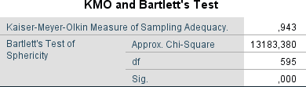

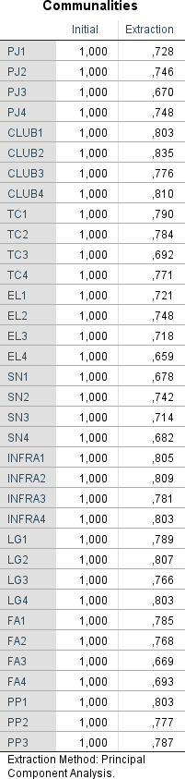

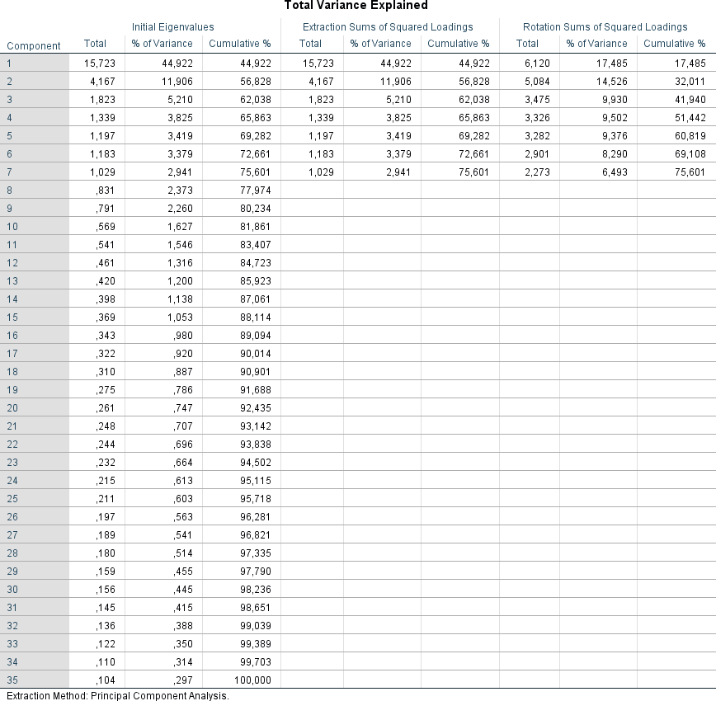

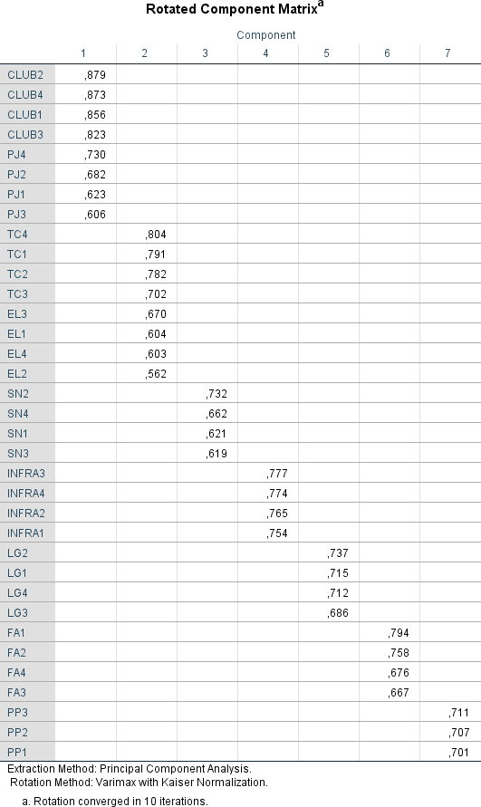

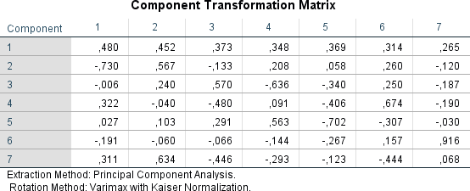

APPENDIX 4: RESULTS OF REGRESSION ANALYSIS

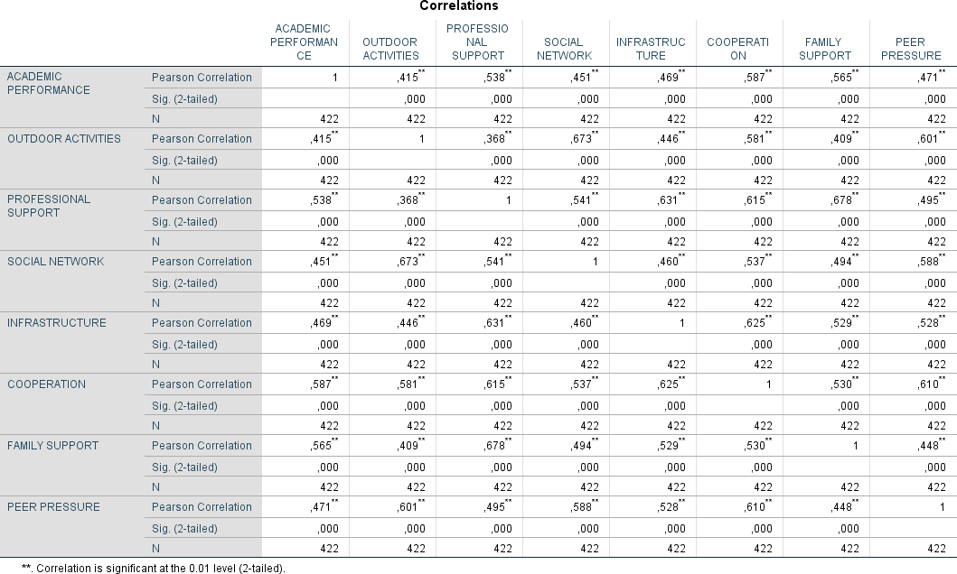

Model Summaryb
Mod el | R | R  Square | Adjusted R Square | Std. Error  of the  Estimate | Durbin- Watson

1 | ,672ª | ,451 | ,442 | ,74695087 | 1,851
a. Predictors: (Constant), Peer pressure, Family support, Cooperation, Infrastructure, Social network, Professional support, Outdoor activities
b. Dependent Variable: Academic performance

ANOVAa
Model |  | Sum of Squares | df | Mean Square | F | Sig.
1 | Regressio n | 190,015 | 7 | 27,145 | 48,652 | ,000^{b}
 | Residual | 230,985 | 414 | ,558
 | Total | 421,000 | 421
a. Dependent Variable: Academic performance
b. Predictors: (Constant), Peer pressure, Family support, Cooperation, Infrastructure, Social network, Professional support, Outdoor activities

Collinearity Diagnosticsa
M  o d e l | Di me nsi on | Eige nval ue | Co ndi tio n Ind ex | Variance Proportions
 |  |  |  | ( C  o ns ta nt  ) | Outd oor activ ities | Prof essio nal supp ort | Soc ial net wo rk | Infr astr uct ure | Co ope rati on | Fa mil y sup por t | Peer press ure
1 | 1 | 1,00  0 | 1,0  00 | ,3  0 | ,08 | ,13 | ,08 | ,25 | ,09 | ,07 | ,00

 | 2 | 1,00  0 | 1,0  00 | ,0  0 | ,00 | ,51 | ,05 | ,42 | ,01 | ,01 | ,00
 | 3 | 1,00  0 | 1,0  00 | ,3  2 | ,01 | ,00 | ,01 | ,00 | ,65 | ,00 | ,00
 | 4 | 1,00  0 | 1,0  00 | ,0  0 | ,20 | ,00 | ,13 | ,00 | ,02 | ,65 | ,00
 | 5 | 1,00  0 | 1,0  00 | ,0  0 | ,00 | ,00 | ,00 | ,00 | ,00 | ,00 | 1,00
 | 6 | 1,00  0 | 1,0  00 | ,0  0 | ,55 | ,16 | ,00 | ,10 | ,01 | ,19 | ,00
 | 7 | 1,00  0 | 1,0  00 | ,3  7 | ,02 | ,08 | ,02 | ,22 | ,23 | ,06 | ,00
 | 8 | 1,00  0 | 1,0  00 | ,0  0 | ,14 | ,12 | ,70 | ,01 | ,00 | ,03 | ,00
a. Dependent Variable: Academic performance

Residuals Statisticsa
 | Minimum | Maximu m | Mean | Std. Deviation | N
Predicted Value | - | 1,160051 | ,000000 | ,67181935 | 422
 | 2,7539837 | 3 | 0
Residual | - | 2,481435 | ,000000 | ,74071504 | 422
 | 3,9391999 | 06 | 00
 | 2
Std. Predicted Value | -4,099 | 1,727 | ,000 | 1,000 | 422
Std. Residual | -5,274 | 3,322 | ,000 | ,992 | 422

a. Dependent Variable: Academic performance

