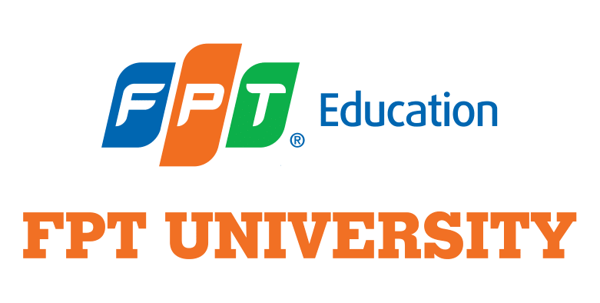
CAPSTONE PROJECT REGISTER

Class: MC1603 Duration time: from 2021 To 2023
(*) Profession: Multimedia Communications Management
(*) Kinds of person make registers: Lecturer ✓ Students

1. Register information for supervisor
 | Full name | Phone | E-Mail | Title
Supervisor 1 | Nguyễn Trần Hương Thảo | 0858588488 | thaonth14@fe.edu.vn​​ | Lecturer
Supervisor 2 | Hoàng Phương Thảo | 0866923864 | thaohp20@fe.edu.vn | Lecturer
2. Register information for students
 | Full name | Student code | Phone | E-mail | Role in Group
Student 1 | Nguyễn Minh Quân | SS160425 | 0913241504 | quannmss160425@fpt.edu.vn | Leader
Student 2 | Nguyễn Hà An | SS160345 | 0819991968 | annhss160345@fpt.edu.vn | Member
Student 3 | Dương Thị Hồng Châu | SS150267 | 0944550807 | chaudthss150267@fpt.edu.vn | Member
Student 4 | Đoàn Hòa Nhã | SS150564 | 0384299945 | nhadhss150564@fpt.edu.vn | Member

3. Register content of Capstone Project
(*) 3.1. Capstone Project Name:
English: “Z Cũng Viết” - A social campaign to reduce stress for Vietnamese Generation Z in Ho Chi Minh City (particularly those aged 18-25) by encouraging them to try relevant writing techniques.
Vietnamese: Chiến dịch truyền thông xã hội “Z Cũng Viết” nhằm giảm stress cho những người thuộc thế hệ Z tại TP. Hồ Chí Minh (đặc biệt trong độ tuổi từ 18-25) bằng cách khuyến khích họ thử các kỹ thuật viết liên quan.
Abbreviation: Z Cũng Viết

(*) 3.2. Main proposal content (including result and product)
- Theory and Practice:
- Executive Summary:
This proposal outlines the “Z Cũng Viết” campaign, a social communications campaign aiming to help Vietnamese Generation Z young adults (aged 18-25) in Ho Chi Minh city afflicted by stress in their daily lives by introducing them to the benefits of writing, and particularly expressive writing, journaling, and creative writing. This works to:
- Enhance their self-expression abilities in daily, academic, and professional contexts to reduce possible stress via inability to communicate.
- Channel their creativity positively to relieve sustained stress.
- Providing them with an outlet for emotional tumult.

Due to project constraints, expertise, and health concerns, we strictly target young adults in Ho Chi Minh City’s vicinity, who may have encountered some degree of stress in their daily lives, but not those who are clinically mentally distressed. This audience is also chosen because of their unique traits and challenges as Vietnam’s first digital natives who are now entering the workforce (this is elaborated upon further below), as well as the team’s familiarity with this target audience.

Below, the proposal will outline the issues faced by the Vietnamese Generation Z young adults, with a focus on stress. It will also present the relevance of writing as a solution to this problem, and will also present the Narrative Persuasion theory as a core tenet of the project. The project’s expected timeline and deliverables are also included.

- Background
  - Challenges faced by the Vietnamese Generation Z Young Adults: A focus on stress
The young adults of Vietnam, aged 18-25, as of 2023, collectively belongs to Generation Z (Dimock, 2019; Thang, 2020; Lee, 2020; Nguyen, 2020). In two years, it is expected that this generation will account for a third of the total Vietnamese workforce (PwC, 2020). The Vietnamese Generation Z is both integrating and disrupting Vietnamese social norms in unique ways. On one hand, Generation Z in Vietnam have been identified to be active in government-led social marketing programs (Truong, 2016) and advocacy for sustainability (Do & Nguyen, 2021), but on the other hand, they have posed challenges to employers with their job-hopping habits and individualistic mindset, desiring strongly work-life balance, in contrast to their previous generations (Thang, 2022).

The Vietnamese Generation Z expresses a variety of positive traits similar to their global peers: digital nativeness, individualism (Thang, 2022), self-expressiveness, openness to change, social consciousness, and concern for sustainability (Nguyen et al., 2022; Do & Nguyen, 2021). However, they are also subject to a multitude of mental health issues from stress to depression and suicidal ideation, while being highly susceptible to high-risk behaviours such as substance use (Minh et al., 2016; Kamimura et al., 2018; Tien et al., 2020; Thai et al., 2020; Dat et al., 2013) and intergenerational conflicts due to ambivalent familial connections and incompatible generational values, on top of the typical conflicts between generations (Swanzen, 2018; Le, 2022; Phuong et al., 2023; Skillman, 1999; Tri & Dung, 2022).

Moreover, as Vietnamese young adults enters this period in their lives, they faces compounded issues from what Arnett (2000) defines as “emerging adulthood”: high susceptibility to partake in substance use (Arnett, 2007; Smith, 2014), sexual identity crisis (Spencer & Patrick, 2007; Lefkowitz et al., 2004; Morgan et al., 2018), stress-related mental health problems (Aquilino et al. (2006); Fingerman et al. (2008)), and a personal identity crisis (Arnett, 2000). Moreover, emerging adults’ relationships to their families may also be in a state of ambivalence (Fingerman et al., 2008).

Among these challenges, stress has become an increasingly pressing concern for the Vietnamese Generation Z in recent years. Kamimura et al. (2018) identified “stress of life” to be the greatest perceived cause of mental illness for Vietnamese college students. This sentiment was echoed in Google’s Year in Search 2022 report (2022), which highlighted a significant increase in the number of stress-relief and mental health related search terms. Louie (2016)’s dissertation found stress to be directly influencing substance use behavior in young adults, as these substances were considered stress relief. Writing, if successfully implemented, can be an effective, healthy, sustainable practice and solving this twofold problem: stress, and substance use.

In short, the target audience can be outlined as follow:
 | Descriptions
Demographics | Generation Z individuals aged 18 to 25.
Location | Ho Chi Minh City, Vietnam.
Background | Students, young professionals, or those engaged in both work and study.
Psychography | Moderately affected by stress (not clinical)

  - Writing: a solution to reduce stress by improving communication skills and productivity in academic & professional settings, and allowing for creative self-expression.
Fundamentally, writing can be defined as the process of composing and organizing thoughts and ideas into written language, involved with making decisions and choices about what to write and how to convey meaning effectively (Flower & Hayes, 1981). With the advent of technology, particularly for college students, Relles and Tierney (2013) proposed that both online and offline contexts contribute to, and are proving grounds of, writing skills, and that interventions concerning writing need to address both online and offline writing. Both Relles & Tierney (2013) and Graham & Harris (2014) suggested that the development of technologies have heightened both the importance of writing and the distress of unskilled writers who have not actively and/or fully developed the skill.

Writing can both prevent and relieve stress by encouraging self-reflection, mindfulness, cognitive processing, and self-expression (Ullrich & Lutgendorf, 2002; Baikie & Wilhelm, 2005). Evidence supporting this has been extensively compiled by Baike & Wilhelm (2005), as well as other research and interventions in art therapy and psychiatry as outlined below.

Term | Definition | Evidence | Foundation
Expressive Writing | Expressive writing involves writing about stressful, traumatic, or emotional events in an active, controlled, and repeated manner.(Pennebaker, 1997) | Many studies show that individuals experience positive mental and physical effects when participating in expressive writing. (Pennebaker, 1997) | Expressive writing gives individuals a structured outlet for their emotions and allow them to cognitively process these emotions and experiences, thus reducing distress and allow them to function better (Pennebaker & Chung, 2012)
Journaling | Journaling involves using a diary or journal to write down daily experiences and emotions (Forsell, 2020) | Forsell (2020)’s study has found positive physical and psychological effects in her participants using journaling, particularly with a focus on cognitive processing and emotional expression. | By granting individuals a private and safe space for expression and reflection, journaling encourages self-reflection, self-awareness, and emotional processing. (Forsell, 2020)
Narrative Writing | Narrative writing involves individuals writing out coherent narratives from their emotions and thoughts towards a distressing event (Forsell, 2020) | Forsell (2020) had also identified positive mental and physical effects in narrative writing participants. | Narrative writing promotes the individual’s ability to unify and process their distressing experiences into a coherent and unified thought process, encouraging understanding and organization of the self (Forsell, 2020)
Creative Writing | Creative writing invokes the creativity and emotions of participants to create new narratives or arts in various written formats. (Forsell, 2020) | Creative writing groups have been found to improve mental conditions of the chronic mental illnesses (Williams et al. 2018) | Creative writing, through providing the individual with self-expression, self-exploration and an opportunity to create, brings about a sense of achievement and well-being (Forsell, 2020)
Writing Therapy | Writing therapy involves disclosing emotions in writing, in a formal environment, with a psychiatrist (but can sometimes be self-initiated) (Wright & Chung, 2001) | Writing therapy has been found to reduce post-traumatic stress (Emmerick, 2012) and also effective for non-clinical and clinical settings ( Baikie & Wilhelm, 2005) | Writing therapy employs cognitive restructuring to help individuals make sense of their emotions and experiences, helps them organize and express their thoughts in a healthy way, and helps individuals to self-reflect. (Ullrich & Lutgendorf, 2002)
Table 1: Forms of writing, evidence, and core mechanisms.

Journaling and Creative Writing are particularly valuable for the project, as these are both popular interventions and can be done casually. While the remaining approaches are reserved for clinical settings, insights into their core mechanisms are also useful for crafting messages and activities further into the campaign.

Particularly relevant to the issue of stress for the Vietnamese Generation Z’s young adults is the well-proven ability of writing to relieve stress in higher education (Nadrah & Suwarjo, 2023; Buckley et al., 2021). More positively, writing in general also improves confidence in self-expression and communication abilities (Demirçivi, 2020; Zhou et al., 2022), skills which Generation Z need for their self-expression desires, and for their professional activities. Tran & Nguyen (2021), in a research consisting of Vietnamese university students, found that the majority of students reported increased relaxation and confidence after engaging in writing and sharing their thoughts online. Moreover, because of writing’s versatile nature (Putra, 2023; Traylor et al., 2020), it relates closely to the desire of Vietnamese young adults to seek out informal, personal mental healthcare in contrast to formal care (Nguyen et al, 2019), while also solving the issue of Vietnamese young adults lacking the needed resources or literacy to seek out formal mental healthcare (Desauvaggie et al., 2023).

However, little research on writing habits have been conducted in the Vietnam settings, and the available data indicates a concerning disregard for the skill among Vietnamese young adults. Mai & Bao (2020) have identified a prevalent perceived lack of writing skills and embarrassment when having to write blogs among students at a Vietnamese university. Ha et al. (2023) found that difficulty in expressing ideas has led to writing anxiety. This is not a local phenomenon, Kara (2013) has also identified writing anxiety in an experiment involving Turkish university students, which the students perceived to be because they are not used to writing, and that they do not have the necessary skills. Graham and Harris (2014) stated that academic institutions have not effectively developed writing as a valuable life skill for students. Ultimately, it is impossible to deny the barriers preventing Generation Z from writing actively as a means to reduce stress, improving communication skills and productivity in academic & professional settings, and improving their creative self-expression ability.

- Problem Statement
The problem this social communications project aims to alleviate are three particular problems of Vietnamese Generation Z young adults (between the age of 18 -25): daily-life stress. By helping them express themselves better and providing them with a creative outlet, the project aims to both prevent and relieve stress for the afflicted.

- Objective Statement
Our primary objective can be consolidated as “Helping to reduce stress levels of moderately-affected Vietnamese Generation Z young adults (18-25) in Ho Chi Minh City via encouraging them to explore relevant writing techniques, particularly Journaling and Creative Writing.”

With insights into the benefits of writing, we also set secondary objectives to communicate the most relevant benefits to the target audience, including:
- Communicating the benefits of writing to enhance communication skills.
- Communicating the benefits of writing to develop critical thinking and self-reflection.
- Communicating the benefits of writing to foster creativity.

To achieve these objectives, the project will draw heavily from the theory of Narrative Persuasion. Moreover, a survey will also be conducted to assess market needs and retrieve possible insights to craft the campaign’s key message.

- Objective-achievement tactics: The Narrative Persuasion theory as a core tenet.
Narrative Persuasion is defined by Helena Bilandzik and Rick Bruselle (2012) as “any influence on beliefs, attitudes, or actions brought about by a narrative message through processes associated with narrative comprehension or engagement.” The mechanisms behind narrative persuasion were foundationally established by Green & Brock (2000), who examined in-depth the role of transportation and identification in relation to the persuasive efficiency of narratives, and since, narrative persuasion has been a highly focused subject of research.

In 2018, Hamby et al. have consolidated the known mechanisms of narrative persuasion into a framework as follows:

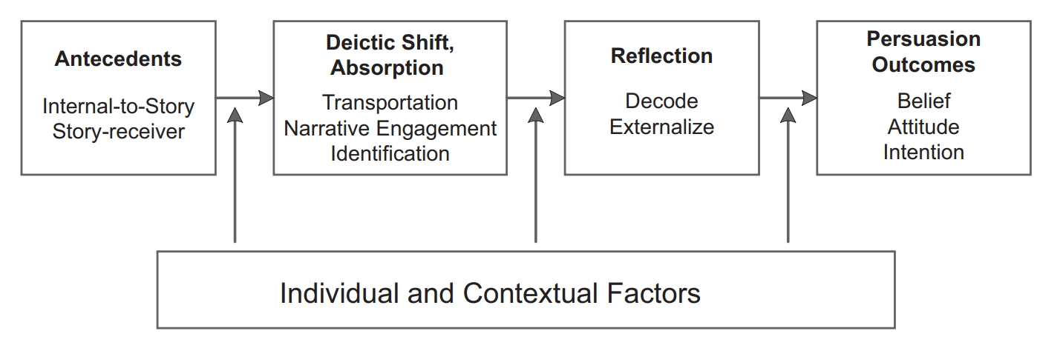
A.Hamby et al., 2018. The narrative persuasion conceptual framework. Absorption and Reflection in Narrative Persuasion. Journal of Media Psychology (2018), 30(3), 113–124.

The Narrative Persuasion process, according to Hamby et al., 2018, occurs in 2 main stages: The Deictic Shift & Absorption of the narrative content, and the Reflection stage in which story receivers contemplate the narrative experience. The extent of the first is determined by Antecedents, and the results of the latter are Persuasion Outcomes.

To date, narrative persuasion has been identified as well as actively utilized in a variety of contexts from public health messages to laboratory experiments. Liang and Tukachinsky (2017) found that online reviews with narrative components are more effective in persuasion than reviews with non-narrative components. In a notable case, Tamul et al. (2010) found news narratives about denormalizing texting while driving to marginally contribute to generating stigma against drivers who engage in texting while driving behavior. In a study of a controversial film, Camino, Igartua and Barrios (2012) found that even religious audiences who underwent narrative absorption positively received messages that went against the concept of religion.

The Narrative Persuasion Theory identifies significantly with our capstone project’s objectives. The finding that narratives can persuade intent, attitudes, and beliefs align strongly with our objective to encourage Generation Z to relieve stress by writing more, and to present writing as a valuable practice with a multitude of benefits to young adults in a sensitive but critical phase in their lives. We aim to achieve this purpose through affecting the target audience’s belief, intent, and attitudes towards writing, utilizing the Narrative Persuasion Theory.

Categories | Goals | Narrative topics
Beliefs | “Writing helps to reduce stress, encourage creativity & improve self-expression abilities”  “Writing is easy, accessible, quick, and beginner-friendly”  “Writing helps me communicate my ideas better”  “Writing helps me to reduce stress” | Stories of how writing have changed the lives of individuals (perhaps young content creators, accomplished young people, or successful young entrepreneurs).
Behavioral Intent | “I can write anywhere, anytime. Writing is my go-to method of expression, creation, and productivity.” | Stories of Vietnamese Generation Z in various contexts using writing to positively deal with the daily toil.
Attitudes towards writing | “Writing is fun, relaxing, and virtuous. When I write, I feel solace, and I can unwind”  “I’d like to get better at writing” | “Spot the writer”-type narratives where the act of young people writing in unusual places/unusual messages are captured.  or  Short-form narratives that identify writing with a release from life stress. Example execution: “Chụp hình slide lại làm gì, rồi về nhà có coi không? Viết nó lại đi bạn ơi, viết xong là nhớ liền!”
Table 2. Objectives & Messaging Ideas

With the Narrative Persuasion Theory as the foundation of our capstone, we set out to conduct a social communications campaign, consisting of: A social media campaign, an offline participatory event, and a storytelling production series.

The development, execution and evaluation of these campaigns will utilize the learned materials of a majority of knowledge domains introduced in FPT University’s Multimedia Communications syllabus, such as Media Psychology, Content Planning, Media Production,... Furthermore, various elements of the project will be supported with other theories and knowledge bodies as follows:

- The project will be managed according to the principles and standards of Project Management (Project Management Institute, 2017). This means the group will develop matrixes and plans to better manage stakeholders and workloads than traditional projects.

- The project will be executed in accordance with the principles of Integrated Marketing Communication. This means the project will undergo rigorous channel selection and target audience segmentation & targeting to ensure effectiveness, while also maintaining campaign & brand integrity.

- Principles of Social Media Marketing will be utilized in the campaign’s scheduling and delivery of messages. This means posting often, with bite-sized narratives, and finding the right platforms. In tandem with this, the Social Media Reactance Model (Huo et al., 2020) to be useful to reduce resistance and increase the effectiveness of advertisement messages, optimizing ad budget usage.

- The Uses and Gratification theory will also be used to tailor communication contents to the audience’s specific usage of the chosen platform.

- The project will be using the principles of Brand Management, to encourage loyalty, advocacy, and love. This means developing a consistent brand identity consisting of visual and textual guidelines, and implementing these guidelines rigorously.

- Situational Crisis Communications Theory (Austin & Yin, 2018) will be used to plan and execute crisis communications, if the need arises. This means proactively brainstorming and categorizing risks (in tandem with the principles and standards of Project Management), and identifying corresponding actions (Denial, Diminish, Rebuild, Bolstering).
- Program:
Section | Timeline | Task Breakdown  (per domain) | Assignee  (*Emboldened individuals are leaders of the respective domain)
Introduction, Research & Development | 18/05/2023 - 25/09/2023 | Management  Team Forming  Topic Selection  Supervisor Selection  Proposal First Draft  Final Capstone Proposal  Project Charter  Meeting & Decision Logs  Management Plans  Work Breakdown Structure  Phase 1 Report | Nguyễn Minh Quân  Nguyễn Hà An  Đoàn Hòa Nhã  Dương Thị Hồng Châu
 |  | Research  Literature Review  Objective & Problem Identification  Theoretical Models Selection  Tactics  Program Outline | Nguyễn Minh Quân  Nguyễn Hà An  Đoàn Hòa Nhã  Dương Thị Hồng Châu
 |  | Campaign  Market Research | Nguyễn Minh Quân  Nguyễn Hà An  Đoàn Hòa Nhã  Dương Thị Hồng Châu
 |  | Production  Idea Development  Script  Storyboard  Licenses & Administrative Procedures | Nguyễn Minh Quân  Nguyễn Hà An  Đoàn Hòa Nhã  Dương Thị Hồng Châu
 |  | Event  Brainstorm Ideas  Research about ideas  Agenda  Build detailed script  Find sponsors | Nguyễn Minh Quân  Nguyễn Hà An  Đoàn Hòa Nhã  Dương Thị Hồng Châu
Pre-Production | 07/09/2023 - 04/10/2023 | Management  Human Resources  Project Timeline  Project KPIs  RAM chart  Stakeholder Communications Plan  Budget & Resource Allocation  Risk Management  Contracting  Creating the Capstone Project Report  Kick-off meeting  Phase 2 Report | Nguyễn Minh Quân  Nguyễn Hà An  Đoàn Hòa Nhã  Dương Thị Hồng Châu
 |  | Research  Developing SMART objectives  Crafting Insights  Big Idea & Messages  Customer Analysis & Profiling  Channel Analysis & Selection | Nguyễn Minh Quân  Nguyễn Hà An  Đoàn Hòa Nhã  Dương Thị Hồng Châu
 |  | Campaign  Communication Plan  Content Strategy | Nguyễn Minh Quân  Nguyễn Hà An  Đoàn Hòa Nhã  Dương Thị Hồng Châu
 |  | Production  Script  Human Resources Requirements  Budget/Cost  Production Kit (Costume, Talent, Location, Equipment, Props, etc.)  PPL document  Artwork - design kit | Nguyễn Minh Quân  Nguyễn Hà An  Đoàn Hòa Nhã  Dương Thị Hồng Châu
 |  | Event  MC scripts  Human Resources Requirements  Estimated budget  PPL  Checklist for props/tools  Design kit: media productions (such as invitation letter, backdrop, standee, etc.)  Scouting location  Proposal  Please sponsor  Build a communication timeline  Guest list  Set design  Event Layout  Logistics  Risk forecasting | Nguyễn Minh Quân  Nguyễn Hà An  Đoàn Hòa Nhã  Dương Thị Hồng Châu
Production/Implementation & Distribution | 05/10/2023 - 18/10/2023 | Management  Task Coordination  Timeline Management  Communication Facilitation  Issue Escalation  Logistic Management  Content Approval  Quality Control  Information Support  Phase 3 Report | Nguyễn Minh Quân  Nguyễn Hà An  Đoàn Hòa Nhã  Dương Thị Hồng Châu
 |  | Research  Real Time Data Monitoring  Identify Trends  Identify Success Stories  Monitor Audience Engagement | Nguyễn Minh Quân  Nguyễn Hà An  Đoàn Hòa Nhã  Dương Thị Hồng Châu
 |  | Campaign  Start campaign  Adjustments if needed  Report for #3 | Nguyễn Minh Quân  Nguyễn Hà An  Đoàn Hòa Nhã  Dương Thị Hồng Châu
 |  | Production  Shooting  Post  Distribute | Nguyễn Minh Quân  Nguyễn Hà An  Đoàn Hòa Nhã  Dương Thị Hồng Châu
 |  | Event  Executing and managing event | Nguyễn Minh Quân  Nguyễn Hà An  Đoàn Hòa Nhã  Dương Thị Hồng Châu
Post-Production & Evaluation | 19/10/2023 - 26/11/2023 | Management  Closure activities  Documentation  Lessons Learned  Client/Stakeholder Review  Archiving  Phase 4 Report | Nguyễn Minh Quân  Nguyễn Hà An  Đoàn Hòa Nhã  Dương Thị Hồng Châu
 |  | Research  Data Collection & Analysis  Impact Assessment  Recommendation | Nguyễn Minh Quân  Nguyễn Hà An  Đoàn Hòa Nhã  Dương Thị Hồng Châu
 |  | Campaign  Evaluate campaign  Audience feedback  Analyze survey  Report | Nguyễn Minh Quân  Nguyễn Hà An  Đoàn Hòa Nhã  Dương Thị Hồng Châu
 |  | Production  Get KPIs | Nguyễn Minh Quân  Nguyễn Hà An  Đoàn Hòa Nhã  Dương Thị Hồng Châu
 |  | Event  Get KPIs  Feedback  Analyze survey | Nguyễn Minh Quân  Nguyễn Hà An  Đoàn Hòa Nhã  Dương Thị Hồng Châu
Oral Defenses | (TBD) | Oral Defense  Slide  Production Book/Final report  Campaign Content (all)  Production video  Event recap video | Nguyễn Minh Quân  Nguyễn Hà An  Đoàn Hòa Nhã  Dương Thị Hồng Châu

- Other products:
- “Z Cũng Viết” brand kit
- Standee, Banner, Digital Ads, Handheld Paddle Signs
- Production Book
- Sponsorship Proposal
- Leaflets

4. Other comment (propose all relative thing if have)

References
Aquilino, W. S. (2006). Family Relationships and Support Systems in Emerging Adulthood. https://doi.org/10.1037/11381-008

Arnett, J. J. (2000). Emerging Adulthood: A Theory of Development From the Late Teens Through the Twenties. https://doi.org/10.1037/0003-066x.55.5.469

Arnett, J. J. (2002). The Psychology of Globalization. https://doi.org/10.1037/0003-066x.57.10.774

Austin, L. L., & Jin, Y. (2018). Social Media and Crisis Communication. Routledge.

Aytaç Demirçivi, K. (2020). Personal Factors Predicting EFL Learners’ Writing Anxiety. https://doi.org/10.18844/gjflt.v10i4.5104

Baikie, K. A., Geerligs, L., & Wilhelm, K. (2012). Expressive writing and positive writing for participants with mood disorders: an online randomized controlled trial. J Affect Disord, 136(3), 310-319. https://doi.org/10.1016/j.jad.2011.11.032

Baikie, K. A., & Wilhelm, K. (2005). Emotional and Physical Health Benefits of Expressive Writing. https://doi.org/10.1192/apt.11.5.338

Davis, K. (2012). Tensions of identity in a networked era: Young people's perspectives on the risks and rewards of online self-expression. New Media & Society, 14(4), 634–651. doi:10.1177/1461444811422430

Dessauvagie, A. S., Dang, H. M., Nguyen, T. A. T., & Groen, G. (2022). Mental Health of University Students in Southeastern Asia: A Systematic Review. Asia Pac J Public Health, 34(2-3), 172-181. https://doi.org/10.1177/10105395211055545

Dezutter, J., Waterman, A. S., Schwartz, S. J., Luyckx, K., Beyers, W., Meca, A., Kim, S. Y., Whitbourne, S. K., Zamboanga, B. L., Lee, R. M., Hardy, S. A., Forthun, L. F., Ritchie, R. A., Weisskirch, R. S., Brown, E. J., & Caraway, S. J. (2013). Meaning in Life in Emerging Adulthood: A Person-Oriented Approach. https://doi.org/10.1111/jopy.12033

Dimock, M. (2019). Defining generations: Where Millennials end and Generation Z begins. Pew Research Center, 17(1), 1-7.

Do, B., Tran, T., & Nguyen, N. (2021). Renewable Energy Integration in Vietnam’s Power System: Generation Adequacy Assessment and Strategic Implications. https://doi.org/10.3390/en14123541

Fingerman, K. L., Pitzer, L., Lefkowitz, E. S., Birditt, K. S., & Mroczek, D. (2008). Ambivalent Relationship Qualities Between Adults and Their Parents: Implications for the Well-Being of Both Parties. https://doi.org/10.1093/geronb/63.6.p362

Flower, L. and Hayes, J. (1981). A cognitive process theory of writing. College Composition and Communication, 32(4), 365. https://doi.org/10.2307/356600

Graham, Steve; Harris, Karen (2014). Conducting High Quality Writing Intervention Research: Twelve Recommendations. Journal of Writing Research, 6(2), 89–123. doi:10.17239/jowr-2014.06.02.1

Gillen, M. M., Lefkowitz, E. S., & Shearer, C. L. (2006). Does Body Image Play a Role in Risky Sexual Behavior and Attitudes? https://doi.org/10.1007/s10964-005-9005-6

Google (2022). Year in Search 2022 Vietnam. https://services.google.com/fh/files/misc/yearinsearch_vn2022translated.pdf

Huo, H., Liu, Z., & Min, Q. (2020). Social Media Advertising Reactance Model: A Theoretical Review. https://doi.org/10.1108/intr-02-2020-0072

Kamimura, A., Trinh, H. N., Johansen, M., Hurley, J., Pye, M., Sin, K., & Nguyen, H. (2018). Perceptions of Mental Health and Mental Health Services Among College Students in Vietnam and the United States. https://doi.org/10.1016/j.ajp.2018.07.012

Kara, S. (2013). Writing Anxiety: A Case Study on Students’ Reasons for Anxiety in Writing Classes . Anadolu Journal of Educational Sciences International , 3 (1) , 103-111 . Retrieved from https://dergipark.org.tr/en/pub/ajesi/issue/1528/18750

Keyes, C. L. (2005). Mental illness and/or mental health? Investigating axioms of the complete state model of health. J Consult Clin Psychol, 73(3), 539-548. https://doi.org/10.1037/0022-006X.73.3.539

King, L. A. (2001). The Health Benefits of Writing About Life Goals. Personality and Social Psychology Bulletin. https://doi.org/10.1177/0146167201277003

Le, D. T. K. (2022). The Relationship Between Internet Usage Behavior and Communication Activities in Vietnamese Family. https://doi.org/10.26758/12.1.14

Le, M. T., Holton, S., Nguyen, H. T., Wolfe, R., & Fisher, J. (2016). Poly-victimisation and health risk behaviours, symptoms of mental health problems and suicidal thoughts and plans among adolescents in Vietnam. Int J Ment Health Syst, 10, 66. https://doi.org/10.1186/s13033-016-0099-x

Lee, Y.-K. (2020). The Relationship between Green Country Image, Green Trust, and Purchase Intention of Korean Products: Focusing on Vietnamese Gen Z Consumers. Sustainability, 12(12), 5098. MDPI AG. Retrieved from http://dx.doi.org/10.3390/su12125098

Lefkowitz, E. S., Gillen, M. M., Shearer, C. L., & Boone, T. L. (2004). Religiosity, Sexual Behaviors, and Sexual Attitudes During Emerging Adulthood. https://doi.org/10.1080/00224490409552223

Louie, B. (2016). Themes in therapy with emerging adults : A qualitative study. Pepperdine Digital Commons. https://digitalcommons.pepperdine.edu/etd/556/

Martha E. Francis, & Pennebaker, J. W. (1992). Putting stress into words: the impact of writing on physiological, absentee, and self-reported emotional well-being measures. American Journal of Health Promotion, 6, 8. https://doi.org/10.4278/0890-1171-6.4.280

Mai, N., & Bao, D. (2020). Exploring Teachers’ and Students’ Perceptions of and Attitudes Towards the use of Blogs for English Writing Skills at a Vietnamese University. VNU Journal Of Science: Education Research, 36(4). doi:10.25073/2588-1159/vnuer.4402

Minas, H., Edington, C., La, N., & Kakuma, R. (2017). Mental Health in Vietnam. In Mental Health in Asia and the Pacific (pp. 145-161). https://doi.org/10.1007/978-1-4899-7999-5_10

Morgan, E. M. (2013). Contemporary Issues in Sexual Orientation and Identity Development in Emerging Adulthood. https://doi.org/10.1177/2167696812469187

Nadrah, U., & Suwarjo, S. (2023). Effectiveness of Expressive Writing Techniques to Address Academic Stress Through a Group Counseling. https://doi.org/10.2991/978-2-38476-034-3_7

Nguyen, D. T., Dedding, C., Pham, T. T., Wright, P., & Bunders, J. (2013). Depression, Anxiety, and Suicidal Ideation Among Vietnamese Secondary School Students and Proposed Solutions: A Cross-Sectional Study. https://doi.org/10.1186/1471-2458-13-1195

Nguyen Dinh Nhu Ha, Nguyen Loc, Tran Tuyen, Tran Thi Ai Huong. (2023). Factors causing writing apprehension among English-majored students. Vietnam Journal of Education Science. 19(2), 40-54. Retrieved from: http://vjes.edu.vn/sites/default/files/vjes_-_vol_19_-_issue_02_-_no_04-40-54.pdf

Nguyen, L.H. and Nguyen, H.P. (2020), "Generation Z in Vietnam: The Quest for Authenticity", Gentina, E. and Parry, E. (Ed.) The New Generation Z in Asia: Dynamics, Differences, Digitalisation (The Changing Context of Managing People), Emerald Publishing Limited, Bingley, pp. 135-148. https://doi.org/10.1108/978-1-80043-220-820201014

Nguyen MTT, Nguyen LH, Nguyen HV. Materialistic values and green apparel purchase intention among young Vietnamese consumers. YC. 2019; 20: 246–263. https://doi.org/10.1108/YC-10-2018-0859

Nguyen Ngoc, T., Viet Dung, M., Rowley, C., & Pejić Bach, M. (2022). Generation Z Job Seekers’ Expectations and Their Job Pursuit Intention: Evidence From Transition and Emerging Economy. https://doi.org/10.1177/18479790221112548

Nguyen, T., Tran, T., Tran, H., Tran, T., & Fisher, J. (2019). Challenges in Integrating Mental Health into Primary Care in Vietnam. In Innovations in Global Mental Health (pp. 1-21). https://doi.org/10.1007/978-3-319-70134-9_74-1

Pennebaker, J. W. (2016). Writing About Emotional Experiences as a Therapeutic Process. Psychological Science, 8(3), 162-166. https://doi.org/10.1111/j.1467-9280.1997.tb00403.x

Pennebaker, J. W., & Chung, C. K. (2012). Expressive Writing: Connections to Physical and Mental Health. In The Oxford Handbook of Health Psychology (pp. 417-437). https://doi.org/10.1093/oxfordhb/9780195342819.013.0018

Pham, N. C., Li, Y., Hossain, T., Schapsis, C., Pham, H. H., & Minor, M. (2020). Understanding Mental Health Services and Help-Seeking Behaviors Among College Students in Vietnam. Asia Pacific Journal of Health Management, 15(3), 58-71. https://doi.org/10.24083/apjhm.v15i3.353

Pham Tien, N., Pham Thanh, T., Nguyen Hanh, D., Duong Hoang, A., Bui Dang The, A., Kim Bao, G., Dang Huong, G., Thi Thu, H. N., Pham Ngoc, H., Nguyen Thi Thanh, H., Bui Phuong, L., Dao Thi Dieu, L., Nguyen Xuan, L., Pham Van, T., Hoang Gia, T., Ha Thi, T., Duong Viet, T., Nguyen Huu, T., & Hoang Van, M. (2020). Utilization of mental health services among university students in Vietnam. International Journal of Mental Health, 50(2), 113-135. https://doi.org/10.1080/00207411.2020.1816114

Phuong, H. Y., Le, T. T., Ho, P. T., & Do, T. N. (2023). English Major Undergraduates’ Unsatisfactory Practicum Experience: a Case Study in Vietnam. https://doi.org/10.52296/vje.2023.244

Project Management Institute. (2017). A guide to the Project Management Body of Knowledge (PMBOK guide) (6th ed.). Project Management Institute.

PwC (2020). How digital ready is Generation Z?. https://www.pwc.com/vn/en/publications/2021/pwc-vietnam-digital-readiness-genz-en.pdf

Ritchie, R. A., Meca, A., Madrazo, V. L., Schwartz, S. J., Hardy, S. A., Zamboanga, B. L., Weisskirch, R. S., Kim, S. Y., Whitbourne, S. K., Ham, L. S., & Lee, R. M. (2013). Identity Dimensions and Related Processes in Emerging Adulthood: Helpful or Harmful? https://doi.org/10.1002/jclp.21960

Relles, Stefani R.; Tierney, William G. (2013). Understanding the Writing Habits of Tomorrow’s Students: Technology and College Readiness. The Journal of Higher Education, 84(4), 477–505. doi:10.1353/jhe.2013.0025

Roberts, B. W., & Davis, J. P. (2016). Young Adulthood Is the Crucible of Personality Development. https://doi.org/10.1177/2167696816653052

Sandback Forsell, J., Nyholm, L., & Koskinen, C. (2021). A caring science study of creative writing and human becoming. Scand J Caring Sci, 35(1), 156-162. https://doi.org/10.1111/scs.12830

Schroth, H. (2019). Are You Ready for Gen Z in the Workplace? https://doi.org/10.1177/0008125619841006

Schulenberg, J. E., & Zarrett, N. R. (2006). Mental Health During Emerging Adulthood: Continuity and Discontinuity in Courses, Causes, and Functions. https://doi.org/10.1037/11381-006

Schwartz, S. J., Zamboanga, B. L., Luyckx, K., Meca, A., & Ritchie, R. A. (2013). Identity in Emerging Adulthood. https://doi.org/10.1177/2167696813479781

Smith, D. C., Bahar, O. S., Cleeland, L. R., & Davis, J. P. (2014). Self-Perceived Emerging Adult Status and Substance Use. https://doi.org/10.1037/a0035900

Spencer, S. M., & Patrick, J. H. (2009). Social Support and Personal Mastery as Protective Resources During Emerging Adulthood. https://doi.org/10.1007/s10804-009-9064-0

Swanzen, R. (2018). Facing the Generation Chasm: The Parenting and Teaching of Generations Y and Z. https://doi.org/10.18357/ijcyfs92201818216

Thai, T. T., Vu, N. L. L. T., & Bui, H. H. T. (2020). Mental Health Literacy and Help-Seeking Preferences in High School Students in Ho Chi Minh City, Vietnam. School Mental Health, 12(2), 378-387. https://doi.org/10.1007/s12310-019-09358-6

Tran, T. M. L., & Nguyen, T. T. H. (2021). The Impacts of Technology-based Communication on EFL Students’ Writing. AsiaCALL Online Journal, 12(5), 54-76. Retrieved from https://www.asiacall.info/acoj/index.php/journal/article/view/80

Tran, Thi Tuyet (2013). Limitation on the development of skills in higher education in Vietnam. Higher Education, 65(5), 631–644. doi:10.1007/s10734-012-9567-7

Traylor, C. S., Johnson, J. D., Kimmel, M. C., & Manuck, T. A. (2020). Effects of psychological stress on adverse pregnancy outcomes and nonpharmacologic approaches for reduction: an expert review. Am J Obstet Gynecol MFM, 2(4), 100229. https://doi.org/10.1016/j.ajogmf.2020.100229

Trong Luan NGUYEN, Minh Khang HUYNH, Nguyet Nuong HO, Tran Gia Bao LE, Nguyen Duy Hau DOAN. Factors Affecting of Environmental Consciousness on Green Purchase Intention: An Empirical Study of Generation Z in Vietnam. Journal of Asian Finance, Economics and Business, Vol. 9, No. 1. 2022. 0333–0343

Truong, V. D. (2016). Government-Led Macro-Social Marketing Programs in Vietnam. https://doi.org/10.1177/0276146716660833

Turner, A. (2015). Generation Z: Technology and Social Interest. https://doi.org/10.1353/jip.2015.0021

Ullrich, P. M., & Lutgendorf, S. K. (2002). Journaling About Stressful Events: Effects of Cognitive Processing and Emotional Expression. Annals of Behavioural Medicine, 24, 7.

van Emmerik, A. A., Reijntjes, A., & Kamphuis, J. H. (2013). Writing therapy for posttraumatic stress: a meta-analysis. Psychother Psychosom, 82(2), 82-88. https://doi.org/10.1159/000343131

Wood, A. M., Froh, J. J., & Geraghty, A. W. (2010). Gratitude and well-being: a review and theoretical integration. Clin Psychol Rev, 30(7), 890-905. https://doi.org/10.1016/j.cpr.2010.03.005

Wren-Lewis, S., & Alexandrova, A. (2021). Mental Health Without Well-being. J Med Philos, 46(6), 684-703. https://doi.org/10.1093/jmp/jhab032

Wright, J., & Chung, M. C. (2010). Mastery or mystery? Therapeutic writing: A review of the literature. British Journal of Guidance & Counselling, 29(3), 277-291. https://doi.org/10.1080/03069880120073003

Zhou, J., Wang, S., & Wang, J. (2022). Investigating High Schoolers’ L2 Writing Anxiety, L2 Writing Self-Efficacy, L2 Writing Self-Regulated Strategies, and L2 Writing Engagement: Relationships and Mediator. https://doi.org/10.3389/fpsyg.2022.1012407

Supervisor (If have)  (Sign and full name)  Nguyen Tran Huong Thao  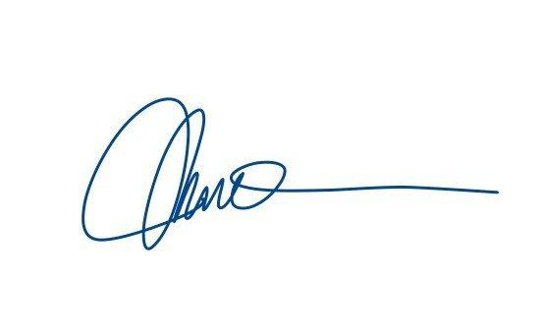  Hoang Phuong Thao | HCMC, Wednesday, 23/08/2023  On behalf of Registers  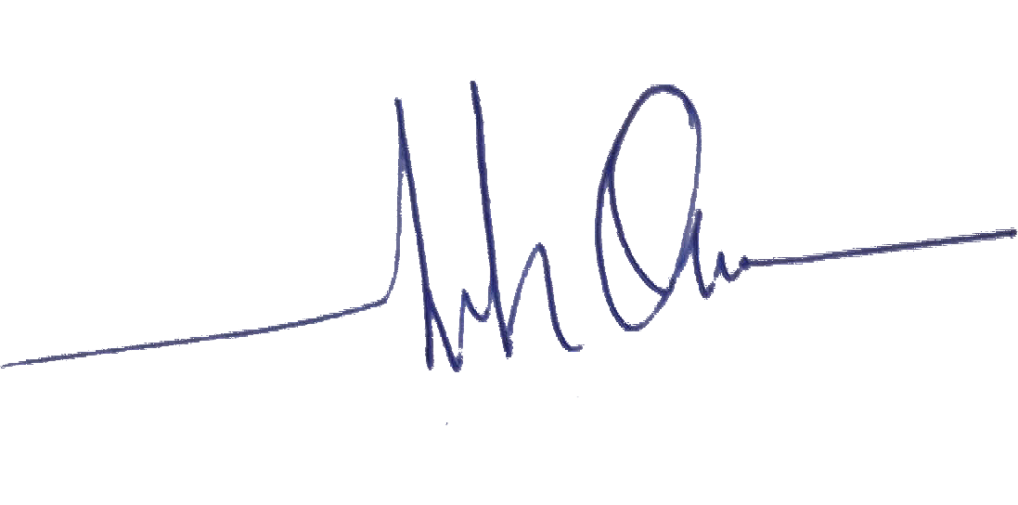  Nguyễn Minh Quân

